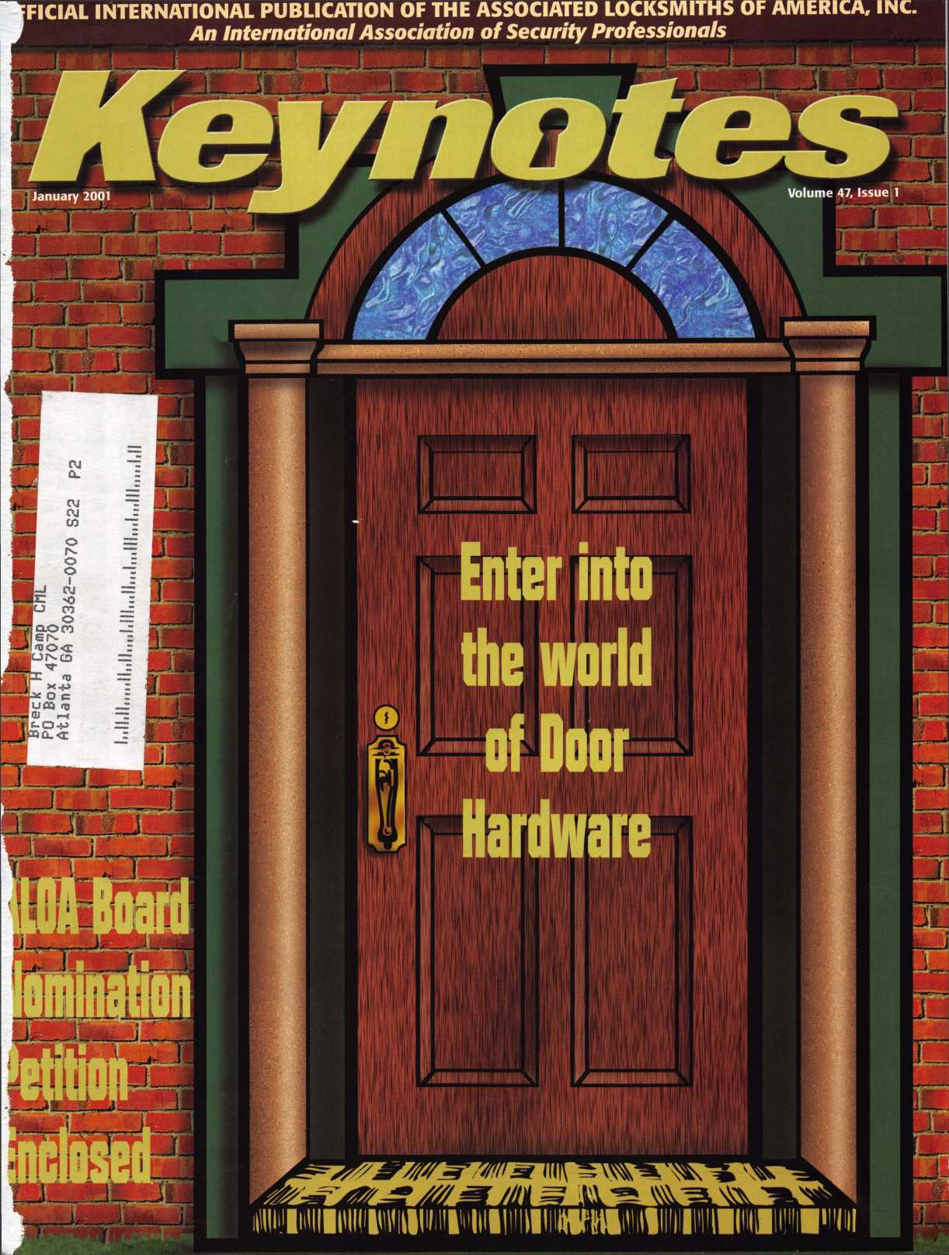

|  |  |  |  |  |  |  |
| --- | --- | --- | --- | --- | --- | --- |
|  | -v r |  |  | nr |  | If |
|  |  |  |  |  |  |  |

**Jump ahead of the competition  
at warp speed and see your profits soar.**

**Hickok’s New Generation STAR transports you with its advanced programming  
for keys to Ford-Lincoln-Mercury vehicles with passive antitheft systems.**

**Program vehicle keys through MY2000 with Hickok’s NGS Model 800-8LA—$1995**

**HICKOK**

phone 800/342-5080  
[www.hickok-inc.com](http://www.hickok-inc.com)

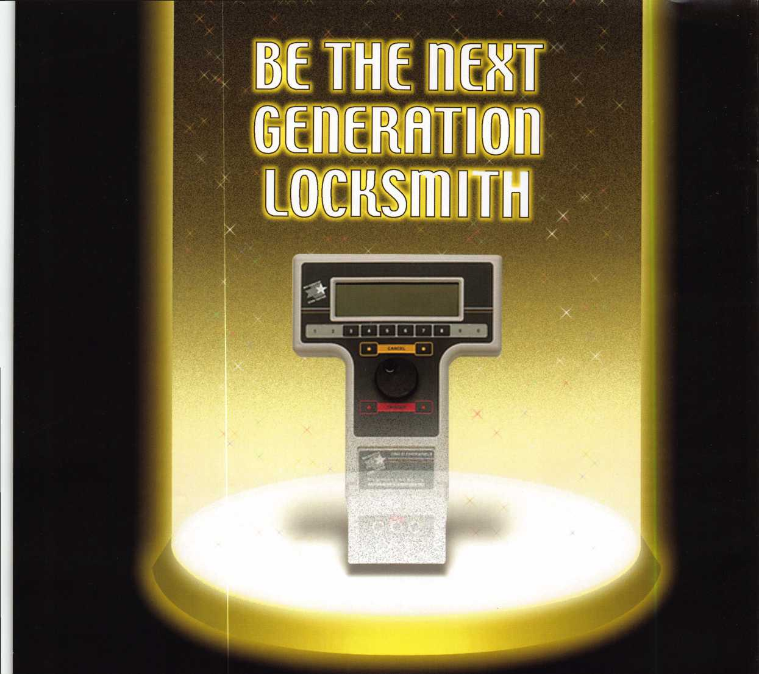

*Visit our Website on  
www. stamcctv. com*

THE COMPLETE

CCTV PROGRAM ON CD-ROM  
FOR STAFF TRAINING AND

PRODUCTIVITY ENHANCEMENT

STAM Insight has been  
developed to enhance CCTV  
skills and productivity with

many different uses.

I# Productivity

It System Drawing II Estimation # CCTV Training It CCTV Reference t# Sales/Demo System Design it Staff Evaluation

**1NFOMATE WORKMATE**

**ULTIMATE**

CCTV Content

*CCTV Calculators* Demonstration Tool

Estimation

Drawing

Internet Enabled

«i:

Pre-Test

Quizzes

*Kno*wledge Assessment

**Sold in Over 50 Countries**



3003 Live Oak Street  
Dallas,Texas 75204

□ Yes, please send me a FREE PREVIEW CD ROM $9.95 S/H

Name:

Job Title:

Organization:

Address:

Zip/Postcode

Country e-mail

Tel: ( ) Fax: ( )

COPYRIGHT © 1996 Security Training and Marketing Pty Ltd. All rights reserved ACN 057 006 541

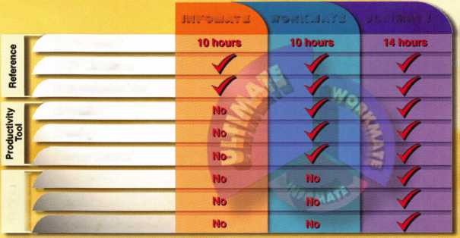

**January**

Features

4

President’s Journey

13

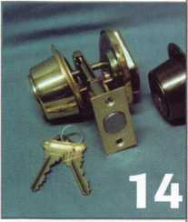

Should Calendar Advertising Be A Part of Your Marketing Plan Learn how to advertise year round from one source. Will calendar advertising work for you? Read this article and get your answers.

By Claire L. Cohen, CML

14

The BC160 Deadbolt

Read about the new deadbolt that will replace Schlage’s B100 line. Take a look at the changes and improvements to this new line. This article gives details on the enhancements and differences between these deadbolt locks.

By Sal Dulcamara, CML

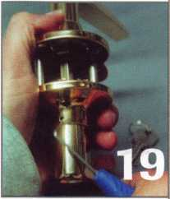

19

Brass & Brass Residential Door Hardware New residential door hardware that may level the playing field for locksmiths.

By Sal Dulcamara, CML

26

Continuous Geared Hinges

Take a look at what is needed to extend the life

of high traffic doors.

By Bob Crank

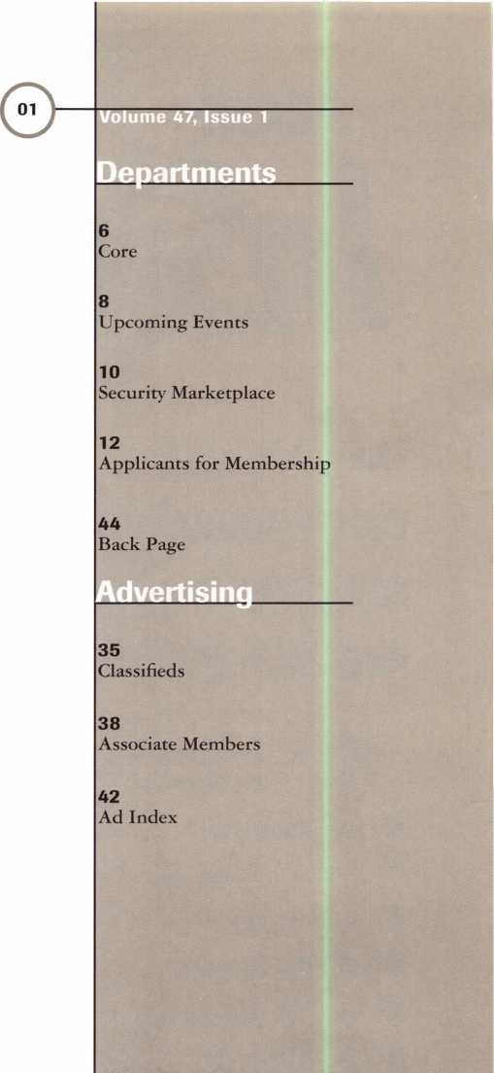

29

ALOA Board Nomination Petition

31

How To Manage Younger Workers Having problems with your younger employees? If so, learn how to manage this new generation of workers.

By Joseph Arkin

Art direction/design Phoenix Design 972.479.9026

ConQuest Graphixs

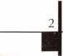

Keynotes

817.285.0003

January 2001



|  |  |
| --- | --- |
| Technical Editor | David Lowell, CML, CMST [david@aloa.org](mailto:david@aloa.org) |
| Managing Editor | Patanya Johnson [editor@aloa.org](mailto:editor@aloa.org) |
| Editorial Advisor | John D. Cannon, CML j [dcannon@worldnet.att](mailto:dcannon@worldnet.att). net |
| Advertising Sales | Marvin Diamond  Native American Journal Co. (770) 993-3544 [thediamonds@mindspring.com](mailto:thediamonds@mindspring.com) |
| Contributing Editors | Paul Chandler, CRL  Claire Cohen, CML  Sal Dulcamaro, CML |
| Contributing Authors | Jerome V. Andrews, CML  Brian Costley, CML, CMST  Bob De Weese, CPL  Ray D’Adamo, CML  Michael A. Ferrill  James Glazier, CML  Daniel Graffeo, CRL, CMST Wayne Gurnee, CRL  A.J. Hoffman, CML  Ken Holmlund, CRL  Ray Lusk, CML  Mark Ohno  Randy Simpson, CML  Robert Stafford, CPL  Dave Thielen, CML |
| Executive Director | Charles W. Gibson, Jr., CAE [charlie@aloa.org](mailto:charlie@aloa.org) |
| Operations/Membership Manager | Mary May [mary@aloa.org](mailto:mary@aloa.org) |
| Membership Coordinator | Shelly Jett |
| Mail Room Coordinator | Emmett McCrohan |
| Comptroller | Kathy J. Romo |
| Accounting Coordinator | Kathy Stokes |
| Government Affairs Manager/ Chapters & Regional Associations Liaison | Tim McMullen [tim@aloa.org](mailto:tim@aloa.org) |
| PRP/Education Manager | David Lowell, CML, CMST [david@aloa.org](mailto:david@aloa.org) |
| PRP/Education Coordinator | Ashley Manson |
| Meeting Coordinator | Thom Terry |
| Information Systems Manager | Randy McChristian |
| Network Specialist | Greg Jackson |
| Receptionist | Alin Valdez |

Executive

Additional contact information for the ALOA Board and most Keynotes authors is available through “Locksmith Search"' on the ALOA website- [www.aloa.org](http://www.aloa.org) or by contacting the ALOA office at 3003 Live Oak Street; Dallas, TX 75204; C800)532-2562;

FAX (214)827-1810; e-mail [aloa@aloa.org](mailto:aloa@aloa.org).



Mission Statement: The Associated Locksmiths of America, Inc. is dedicated to enhancing the professionalism, education and ethics among locksmiths and those in related sectors of the physical security industry. With approximately 10,000 members in the United States, Canada and the freeworld, ALOA is poised to help members obtain the knowledge, the strength, and the confidence to perform their role in the physical security field with pride and dignity. But it is only through active involvement and participation that ALOA can fully achieve its potential-and can help members to achieve theirs.

Policies: Keynoted is the official publication of the Associated Locksmiths of America, Inc. (ALOA}. Keynoted acts as a moderator without approving, disapproving, or guaranteeing the validity or accuracy of any data, claim, or opinion appearing under a byline or obtained or quoted from an acknowledged source. The opinions expressed by the authors do not necessarily reflect the official views of ALOA. Also, appearance of advertisements and new products or service information does not constitute an endorsement of products or services featured by the Association. The Association does not accept responsibility for the inaccuracy of any data, claim, or opinion appearing in this publication, due to typographical errors on the part of the authors, Association staff or its agents. Editor’s Note: This publication is designed to provide accurate and authoritative information in regard to the subject matter covered. It is provided and disseminated with the understanding that the publisher is not engaged in rendering legal or other professional services. If legal advice and other expert assistance is required, the services of a competent professional should be sought.

Authors’ Payment: Payment for eligible submissions to Keynotes will be based on the following criteria: topic, time spent and past contributions. Authors who regularly submit to Keynotes are generally paid a higher rate. The latter is especially true of authors who write to fit specific editorial needs and submit said copy by Keynotes deadlines. As a general guideline: Average payment for a 750 word, business or ‘light’ technical article would be $200. Payment for a 1500 word article involving significantly higher time and research efforts would be $400.

Payment will not be offered for articles submitted by ALOA employees or members of the ALOA Board of Directors (unless material is of a technical nature}, nor for articles submitted by a company that promote that company’s products or services. ALOA reserves the right not to pay for articles submitted by an individuals} that promote a particular company’s products or services.

Disclaimer: The Associated Locksmiths of America, Inc., (ALOA}, reserves the right to refuse any article for any reason. Additionally, ALOA reserves the right to edit, amend or modify any article submitted for publication in order to preserve technical accuracy, clarity, fairness or grammatical correctness. ALOA will make the best efforts to notify the author of any changes. The extent of ALOA’s liability for any article or information contained therein will be a notice of correction or retraction in the next possible issue.

Keynoted (ISSN 0277 0792} is published monthly except for the combined June/July issue by The Associated Locksmiths of America, Inc., 3003 Live Oak St., Dallas, TX 75204-6186. Telephone: (214} 827-1701; FAX (214} 827-1810; e-mail [aloa@aloa.org](mailto:aloa@aloa.org). Subscription rates for members-$15.00 per year. Second class postage paid at Dallas, Texas. POSTMASTER: Send address changes to: Keynotes, 3003 Live Oak St., Dallas, TX 75204-6186. © Copyright 1999, All rights reserved. No part of the contents may be reproduced or reprinted in any form without prior written permission of the publisher.

Soard



President

John J. Greenan, CML, CPS (773} 486-2030

Secretary

John D. Cannon, CML (703} 960-6413

Directors, Northeast

John C. Magee, III (856} 845-3434 Peter Sarailian, CRL (201} 947-6291 William L. Young, CML (610} 647-5042

Directors, Southeast

Thomas W. Tate (850} 476-4211 Donald E. Rule, CML (601} 324-2658

Directors, North Central

Mark E. Blum, CML, CPS (517} 482-5809 Tom Ripp, CRL (608} 262-3831

Director, South Central

Randy L. Simpson, CML (713} 780-7026

Directors, Southwest

Gordon R. Racine, CML (719} 384-4707 John A. Ilk, CRL (602} 420-2174

Director, Northwest

Scott L. Henke, CRL, CPS (907} 248-3785

Director, Associate Members

David F. Matthies (727} 541-5536

Trustees

Dallas Brooks

(334} 826-8990

David M. Lowell, CML, CMST

(800} 532-2562

Breck H. Camp, CML

(770} 455-6244

Edwin Toepfer, RL

(416} 225-5589

Past Presidents

1997-1999 Dallas C. Brooks 1995-1997 David Lowell, CML, CMST 1993-1995 Breck Camp, CML 1991-1993 Henry Printz, CML 1989-1991 Evelyn Wersonick, CML, CPS 1987-1989 Leonard Passarello, CPL 1985-1987 Joe Jackman, CML 1983-1985 Stanley Haney, CPL 1981-1983 Louis LaGreco, CPL 1979-1981 John Kerr, RL 1977-1979 Clifford Cox, CML 1974-1977 Charles Hetherington 1972-1974 Gene Laughridge 1970-1972 William Dutcher, RL 1968-1970 Constant Maffey, RL 1966-1968 Harold Edelstein, RL 1964-1966 William Meacham 1962-1964 Robert Rackliffe, CPL 1960-1962 Edwin Toepfer, RL 1956-1960 Ernest Johannesen

January 2001

Keynotes

Happy New Year!

with John J. Greenan

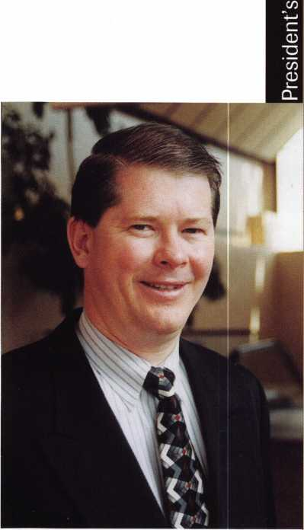

Every year I make at least one New Years Resolution that is both professional and personal. This year I resolve to get my column for Keynotes in on time. This helps me on two fronts: it makes me a better person, and it allows me to give back to the industry which Eve enjoyed working in since 1985. In 1993, I made a resolution that forever changed my life: I wanted to serve on the ALOA Board of Directors. At that time, I had no idea that I would be President of the association someday, but it has made that resolution all the better. Now I’m asking you to make the same resolution.

In this issue of Keynotes on page 29 there is a Board nomination form. Through historic changes made to the bylaws in 1998, the Board is now open for ALOA members to directly run for office and lead this association into the new millennium. A minimum number of ALOA members must sign your petition, and then your hat is in the ring! This year we will be electing ALOA Directors from the Southwest, North Central and Southeast regions. We will also be electing a new ALOA President.

But why run? Because ALOA and the security industry needs you. Although being an ALOA board member includes contributing a moderate amount of personal time, it offers you a chance to bring a significant degree of professional guidance and expertise to the organization. The security industry is going through a critical time. ALOA needs leaders with an outward vision, intelligence, and tolerance. Leaders with a commitment to equity and equality, reliability, dependability, honesty and the ability to take action. In other words, a typical ALOA member like you!

What do you get out of being an ALOA Board member? The opportunity to help shape this associations’ commitment to its members. To meet and interact with security professionals from all over the country. And most of all, the professional satisfaction that you are playing an important role in the industry and the personal satisfaction that you are giving something back to it.

I urge you to seriously consider running for a Board position this year. Even the experience of running is a rewarding one. Who knows, you may even end up being ALOA’s new President!

Sincerely,

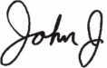

John J. Greenan, CML, CPS

January 2001

***A*** Keynotes



Associated Locksmiths of America

|  |  |
| --- | --- |
| Member Name | Number of Sponsorships |
| Kwok-kei Leung | 202 |
| Toshihiro Asano | 108 |
| Henry W Raymond | 93 |
| Yuriko Yanai | 68 |
| Mary S Ohmit CPL | 66 |
| Charles C Robertson CML | 65 |
| Jack Hobin CPL | 51 |
| William B Neff CML | 43 |
| Salvatore J Dulcamaro CML | 40 |
| Myeong-Rae Cho | 38 |
| Dana L Barnum CML | 35 |
| Barry K Leas CRL | 35 |
| Danny W Rudd CPL | 31 |
| Larry A Wamick CML | 31 |
| Jeanne G Lodge CML | 31 |
| C Allan Halverson | 29 |
| Anthony J Ramunno CML, CPS | 26 |
| James M Watt CML, CPS | 26 |
| Jeffrey S Nunberg CML, CMST | 26 |
| J Thomas Hood CML | 26 |
| Jim Williams CRL | 26 |
| Lawrence F Smith Jr, CML | 25 |
| James H Glazier Sr, CML | 25 |
| Robert H Stafford CPL | 25 |
| William Lee | 25 |
| John C Elliott Jr, CML | 24 |
| Jerome L Cohen CML | 23 |
| Peter K Gauthier CPL, CPS | 23 |
| Robert F Carroll CPL | 23 |
| Robert D DeWeese CML | 23 |
| Marian M Swann CRL | 22 |
| Diana R Barnum CRL | 22 |
| Elvis D Hammerschmidt CPL | 22 |
| James J Cawby CML, CPS | 21 |
| Eugene R Altobella Sr | 21 |
| John L Shandy CML | 19 |
| Hans Mejlshede CML | 19 |
| John S Dorsey CML | 19 |
| D Michael Lee Sr, CPL | 18 |
| James E Fowler Sr, CML | 18 |
| David C Harris CML | 18 |
| Philip A Rovenolt CPL | 18 |
| Peter R Hall | 17 |
| Thomas G Vandersteen CML, CPS 17 | |
| William P Grant CRL | 17 |
| Keizo Takahashi CRL | 17 |
| Evelyn V Wersonick CML, CPS | 16 |
| Joseph P Ferrero CML | 16 |
| Gary F Teams CPL | 16 |
| Robert W Duman Sr, CML | 16 |
| Michael D Robinson CRL | 16 |
| Brian J Reetz | 16 |
| Maurice Benson | 16 |
| Walter W Lascar RL | 15 |
| William J McElheney CML | 15 |
| Russell P Fuller CRL | 15 |
| Michael B Groves | 15 |
| Daniel L Landry Jr | 15 |

Robert C Rodocker CRL James E Gruber CRL Michael E Jordan Jr, CML Jon B Griswold CML James T Brickler CRL Man S Seo

Joseph C Fuller CPL, CMST

Leonard J Passarello CPL

Frank D Hartung CML

Joseph W Whitaker CPL

Robin A Horsley

Paul M Souber

Donald H Shiles RL

Richard C Sievers

JoeJ Lee CRL

Ernest W Wright

Rolando Bouza

Raymond C Lusk CML

John F Engel CRL

Eric F Veal

Basil W Shannon CPL

William J Wickward CML

Calvin G Harris CML

Herbert C Dusenberry CML, CPS

Timothy K Chow

Dale L Knowles CPL

Thomas J Demont CML, AHC

Alvin N Minor

Gene Eldridge CPL

Ronald P Riggins CML

Lester S Brodsky

Larry L Votaw CML

Thomas R Smith CPL

Richard T Johnson CPL

Dale V Crosby CPL

James V Hawley CRL

Brightest

And The Best.

How can I join the President's Club?

You can earn membership in this prestigious dub by recruiting just 10 new members for ALOA.

*Any ALOA member may participate.

What do I get?

When you recruit 10 members, you receive a handsome blue blazer with a President's Club crest. For each additional five members you recruit, you receive a lapel pin with gold-filled numbers, indicating your recruiting successes.

You also get the satisfaction of knowing that you are helping your association, helping your industry grow, and you are helping fellow locksmiths achieve success.

How do I get started?

Contact the ALOA office for a supply of applications (800) 532-AL0A or FAX (214) 827-1810. One President's Club credit is awarded for each new applicant. Credit is awarded only after the membership application is approved. However, the credit will apply for the period in which the application is received. Failure to identify yourself as the sponsor on the application form at the time it is submitted to ALOA for processing will forfeit any credit.

*ALOA Board of Directors not eligible for membership in the President's Club.

January 2001

Keynotes



core

•Safemasters On the Move With Growth

Last month Safemasters Co., Inc. acquired the assets of Corbett Lock & Key Co., Inc., a security company operating in Madison, New Jersey. This is the fourth acquisition in the last three years for Safemasters in the state of New Jersey.

Safemasters provides safe, CCTV, access control and door installation service from 15 locations in eight states for locksmiths.

Within the next five years, Safemasters plans to add at least 10 locations in new markets through acquisitions.

By 2005 Safemasters plans to have at least 25 locations in 18 states.

At the present, Safemasters SM Services Division, with the help of approximately 2000 service partners, provides nationwide service in the markets where Safemasters does not have a location.

• 2000 Record Year for Fire King

Things were good in 2000 for Fire King International the New Albany, Indiana company, that makes fireproof cab­inets, safes and surveillance equipment. Fire King is also one of the world’s largest manufactures of commercial safes, sold under the brand names of Meilink Safe, Gary Safe and NKL Safe. The year 2000 is the best year on record for Fire King.

The foundation of Fire King’s success has come in fireproof file cabinets, where sales were approximately 14% higher than the previous year. Much of this growth is attributed to a deal made in October of 1999 with Office Depot, which resulted in the chain carrying Fire King Products in their office supply and furniture stores.

According to Van Carlisle, President and CEO of Fire King, “This is significant growth, especially when you consider that Fire King has been the category leader for quite some time, yet we’re still gaining market share.”

Another area that has seen dramatic growth is the surveillance division with a product called Image Vault. Image Vault uses a computer hard-drive to capture images seen through the cameras of a closed circuit television

system. Image Vault was developed four years ago for Tricon restaurants, which include KFC, Taco Bell and Pizza Hut.

Another Fire King division that saw substantial growth is NKL, which makes safes for retail operations. These “intelligent” safes count money and create an audit trail. One of the most popular products is the Autobank validating safe because it automatically counts cash as it’s deposited in the safe.

Fire King sold its Winchester Guns Safe operation to Granite Security Products in Forth Worth, Texas last month. Winchester was Fire King’s only product that was manufactured exclusively for the consumer market.

Carlisle sees Fire King growing even more in 2001 as the company celebrates its 50th anniversary.

* Briefs

KEY-BAK, a division of West Coast Chain have outgrown their current address. The new location and address is 4245 Pacific Privado, Ontario, Calif. 91761. The post office box address and telephone numbers will remain the same.

The International Association of Professional Security Consultants (IAPSC) announced their Official Endorsement of the International Security Conference & Exposition (ISC Expo) events. ISC Expo is sponsored by the Security Industry Association (SIA). It is also endorsed by the National Burglar and Fire Alarm Association (NBFAA), Central Alarm Association (CAA), International Association of Professional Consultants, (IAPSC), Security Dealer Magazine and Security Magazine.

* Regions

Congratulations to the new officers of the Wyoming Locksmith Association (WLA). President-Larry Capp

Vice-President-Dave Lueras

The Monthly Membership Meeting location of the

Central Florida Locksmith Association has changed to 813 Montana Street, Orlando, Florida 32803.

**M. *Keynotes***

January 2001

• Obits

ALOA regrettably bids farewell to some loyal members and dedicated locksmiths. Our thoughts and prayers go out to the families and friends of the following individuals.

John E. Dietzel, 88, locksmith group leader and business owner. He was a locksmith for Krichbaurn Lock & Mower Inc. in Youngstown and Austintown, Pennsylvania, for more than 50 years. He retired in 1985 as president and co-owner. He was a charter member of ALOA as well as a founding member and president of the Penn-Ohio Locksmith Association.

Sheldon Wiener, a true friend of every Detroit area locksmith lost his battle with cancer on Thanksgiving morning. He worked at Key Sales and Supply before recently moving to Las Vegas.

Alvin F. Hack, 84 was a retired locksmith from East Lansing, Michigan. He was a member of ALOA for over forty years.

Russell Waller, 71, life member and retired Chief of the Physical Security Laboratory for the U.S. Department of State’s world-wide security program. He was an ALOA member since 1963 and spent over 50 years in the locksmith business.

• EXECS



The Greater Alarm Company, Inc.,  
one of California’s largest security  
and fire protection service providers,  
has named Kelly Koelsch as  
System Design Engineer for the  
Loomis, Calif, office. As System  
Design Engineer, Kelly will provide  
initial CAD design of fire, intrusion,

access control and CCTV systems sold by Greater Alarm as  
well as final system designs after the sale is complete.

•PRP

ALOA is offering PRP/STPRP Testing every second Friday of the month at the ALOA Headquarters. We are located at 3003 Live Oak Street; Dallas, Texas. For more information contact Ashley Manson at (214) 827-1701 X30.

We would like to congratulate the following individuals who have recently achieved PRP/STPRP designations.

CRL

Corbett, Nancy S., Maynard, MA Dunsmore, Robert T., Norwalk, CT Killur, Daniel B., Bondville, VT McDonald, Wayne, Centreville, VA Miller, Marshal, Stratham, NH Reid, Robert G., Longwood, FL Sabilia, John, Quaker Hill, CT

CPL

Gater, Jeffrey M., Royal Palm Beach, FL

CPS

Coulombe, Ronald, Chelmsford, MA

**Safes In Stock...  
Ready to Ship**

**amsec FireKing  
Qaidall HAYMAN**

**MEILINK** Y/CTOn

MOREPROFI^FRE^REIGKT

pURfUOl

WHOLESALE SERVICE I

**800-848-9790**

***Our business is helping you sell more safes!***

January 2001

Keynotes

Upcoming

Events



Dept

Indicates ALOA ACE Class p Indicates PRP Sitting

2001

**JANUARY**

12

f? ALOA PPR Sitting Dallas, TX

Contact: Ashley Manson (214) 827-1701 (214) 827-1810 fax

12-14

WLA Annual Banquet & Classes Life Safety Codes & the ADA Wyoming Locksmith Association Contact: Fran McCumber (307)527-5513 17

Mag Installation Evening Seminar

Milwaukee, WI

Clark/ Fox Valley Chapter

**FEBRUARY**

3

Ace Classes

Electronic Safe Lock Class Alabama Locksmith Association Contact: Dallas Brooks (334)826-8990

3-4

West Coast Lock Collectors Show Arcadia, CA

West Coast Lock Collectors Contact: Bob Heilemann (310) 230-3004 evenings (310)454-7295 message

6-11

%r ALOA PRP Sitting Ace Classes (12)

2001 Annual Convention &

Trade Show Austin, TX

Omni Austin Hotel Southpark The Texas Locksmiths Association Contact:

Registration:

Jim Hetchler (380) 606-1727 Exhibits:

Robert Hernandez (210) 433-5397 General info:

Judy Clifford (979) 297-2413

8

f/ ALOA PRP Sitting Dallas, TX

Contact: Ashley Manson (214)827-1701 (214) 827-1810 fax

**MARCH**

4

Southern Lock Trade Show 2001 St. Petersburg, FL Southern Lock & Supply Co. Contact: Missy Whalen (800) 282-2837

9

f/t ALOA PRP Sitting Dallas, TX

Contact: Ashley Manson (214)827-1701 (214) 827-1810 fax

23-25

ALOA Spring Board Meeting Dallas, TX

28-April 1

MLANJ 2001 Annual Convention Ace Classes (17) f/ PRP Sitting Somerset, NJ Convention Contact:

(973)267-8884 (973) 538-2248 fax [www.mlanj.org](http://www.mlanj.org) PRP Contact:

Dan McGlynn, CML (732) 634-4605

April

i

ALOA PRP Sitting Rosemont, IL Clark Security Products Contact: Joan Emrick (619)718-7308

2-4

ASTM Committee FI2 Meeting Security Systems and Equipment Phoenix, AZ

American Society for Testing Materials

Meeting Contact: Jim Olshefsky

(610)832-9714

[jolshefs@astm.org](mailto:jolshefs@astm.org)

Housing: Hyatt Regency

(602)252-1234

4-6

ISC Expo/ West 2001 Las Vegas, NV

Sands Expo & Convention Center

14

f/ ALOA PRP Sitting White Bear Lake, MI Minnesota Chapter of ALOA Contact: Alan Morgan (763) 566-2637

30-May 5

SAFETECH 2001 St. Louis, MO (214)827-7233

**MAY**

10-13

f/ ALOA PRP Sitting

IDN 2001 Trade Show & Security

Conference

Ypsilanti, MI

Contact: Fred Strasberger

(800) 521-0955 or

Bonnie Weston

(734) 591-1150

11

ALOA PRP Sitting Dallas, TX

Contact: Ashley Manson (214)827-1701 (214) 827-1810 fax

**JUNE**

8

ALOA PRP Sitting Dallas, TX

Contact: Ashley Manson (214)827-1701 (214) 827-1810 fax

**JULY**

13

ALOA PRP Sitting Dallas, TX

Contact: Ashley Manson (214)827-1701 (214) 827-1810 fax

15-22

ALOA 2001 Security Expo Baltimore, MD (800) 532-2562

**AUGUST**

**SEPTEMBER**

14

ALOA PRP Sitting Dallas, TX

Contact: Ashley Manson (214)827-1701 (214) 827-1810 fax

OCTOBER

12

ALOA PRP Sitting Dallas, TX

Contact: Ashley Manson (214)827-1701 (214) 827-1810 fax

15-21

Tri Regional Locksmith Conference Portland, OR

Pacific Locksmith Association Contact: Stan Hauer (503)325-7334 Email [hauer@pacifier.com](mailto:hauer@pacifier.com) Contact: Ken Mead (503)873-6932

**NOVEMBER**

9

ALOA PRP Sitting Dallas, TX

Contact: Ashley Manson (214)827-1701 (214) 827-1810 fax

DECEMBER

14

f? ALOA PRP Sitting Dallas, TX

Contact: Ashley Manson (214)827-1701 (214) 827-1810 fax

2002

**JULY**

22-28

ALOA 2002 Security Expo Rosemont, IL (800)532-256

13

fz? ALOA PRP Sitting Dallas, TX

Contact: Ashley Manson (214)827-1701 (214) 827-1810 fax

10

ALOA PRP Sitting Dallas, TX

Contact: Ashley Manson (214)827-1701 (214) 827-1810 fax

Keynotes

January 2001

“If you want to study for the CPS test,

you need this book.

Without that book, I wouldn’t have my certification.”

-Dennis Johnson, CML, CPS  
Aurora, Illinois

"Mike's new book is very  
consistent with the study  
information required to pass the  
SAVTA/ALOA CPS certification  
test. I wouldn't have passed  
without it. *A tremendous  
resource for today  
and tomorrow..."*

-John T. Grist, CML, CPS  
North Georgia Security

"The Safe Technicians Reference Manual by Mike Oehlert ranks among the best technical reference and learning aids you will find in the safe and vault industry. It contains page after page of essential information and easily understood illustrations. Besides answering most of the questions commonly asked by technicians new to the field, Mike has also included plenty of information experienced technicians will find useful "

-Ken Dunckel Pacifica\, California

—►Over **600** Illustrations.^—

320 **pages.** Only $135.

What are you waiting for?

To order, call 800-532-2562. Allow 3 weeks for delivery.

All major credit cards accepted; or make check payable to ALOA.

The Safe

Technicians  
Reference Manual

First Edition

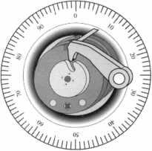

January 2001

Keynotes

Security

Marketplace



Dept

Marks USA

Marks USA introduces their Gold Seal Collection of decorative entry locksets in its Lifetime Warranted Finish. All locksets have a full lifetime

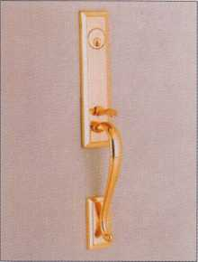

mechanical warranty. This line of entry locksets includes 10 handles, sixteen knobs or levers with complimentary interior designs. For application assistance or brochure contact:

Marks USA

5300 New Horizons Blvd. Amityville, NY 11701 (631)225-5400 (631) 225-6136 fax nancy@marksusa. com

Trine Access Technology

Trine has introduced the world’s smallest electric strike that boast 1200 lbs of holding force. The new

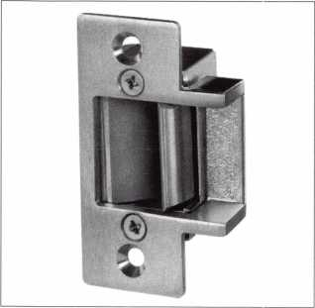

3234 strike which contains the features of larger strikes in a compact 1-11/16” x 1-1/16” x 1” overall strike body. In addition to the 1200 lbs. holding force, it features the smallest backset (1”) in the industry, stainless steel latch and locking mechanism and will accept a 1/2” latch bolt. The faceplate measures 2-3/4” x 1-1/8” and meets the ANSI 115.3 standard. The 3234W strike is recommended for wood applications.

Trine Access Technology 1440 Ferris Place Bronx, NY 10461-3699 (718) 829-2332 (718) 829-6405 fax [customerservice@trineonline.com](mailto:customerservice@trineonline.com)

Napco Security Group

Napco releases a new mini catalog.

The catalog highlights all of the products offered by the following division of the Security Group: Napco



Security Systems, Alarm Lock Systems and Continental Instruments. The catalog is 25 pages in length and contains full color photos of the products, product descriptions and features. Also featured are items such as: Control Panels, Keypads, Sensors, Home Automation Products, Fire Alarm Control Panels, Pull Stations, Smoke Detectors, Digital Access

Locks, Panic Exit Devices and Access Controllers. All of Napco’s new products, the 2-Way Universal LCD Keyfob, IQ Profiler and Trilogy Prox Lock can also be found in the mini catalog. For a copy of the mini catalog (Part # A402A) contact:

NAPCO Customer Service (800) 645-9445

Samsung Opto-Electronics America, Inc.

Samsung announces the release of the SWC-101, a webthru network camera. This new camera is a high performance all-in-one color web camera with

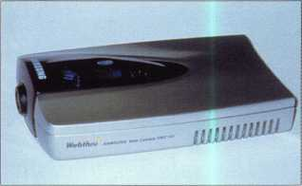

server. It incorporates a web server of embedded Linux and a high performance color CCD camera assembly into a single compact enclosure. The web camera allows over 100 users to simultaneously view video scene anywhere in the world using a standard web browser. SWC-101 Camera features include: High performance, Wavelet Technology, Increased Image Transfer, On-line remote software upgrades, and a MSRP of $999. This camera becomes available this month (January 2001).

Security Lock Distributors

Security Lock increases the complete line of Sentrol mounting contacts in their inventory. Included are surface and recess types, overhead door styles, roller/plunger units with wire leads, steel door terminal and

January 2001

Keynotes

request-to-enter PIR contacts. High security contacts with armor cable, miniature surface units and many other styles are also available for immediate delivery. In addition, Security now stocks Sentrol smoke detectors, carbon monoxide alarms and acoustic glassbreak sensors. Security hock (800) 847-5625 (800) 878-6400 [info@seclock.com](mailto:info@seclock.com)

Lockmasters

Lockmasters announces the release of the ITL-2000IITM Automatic Dialer. This new dialer offers locksmiths and safe technicians unparalleled quality and ease of operation in automatic safe opening. The ITL-2000II includes an easy to use single piece magnetic base for fast, efficient and slip-free mounting. The updated software now includes the ability to perform either left-right-left or right-left-right dialing. The ITL-2000II is available for under $1500.

Lockmasters Inc.

5085 Danville Rd Nicholasville, KY 40356 (800) 654-0637

Dorma Group North America

Dorma introduces the ED 800 low energy operator for ADA compliance through power assist or power open. Dorma’s ED 800 combines a powered door closer with microprocessor control to render and ADA-compliant device that either assists with the opening of a door or opens a door automatically for the physically challenged. The ED 800 can be field adjusted into one of two modes: low energy or power assist. In low energy mode, the activated unity cycles the door open according to four user adjustments-delay time, opening angle, opening time/force and door width. In the power assist mode, the ED 800 supplies powered assistance to manual operation, adjustable between 1/2 lbf and 5 lbf. As an added safety measure, the ED 800 stops operation and enters a balanced state when it encounters an obstacle in the opening or closing cycle. An assist function is automatically engaged to make it

easier to push the door out of the way. The Dorma ED 800 series is listed by U.L. and C.U.L. under their continuing reinspection programs. The series is certified to the requirements of ANSI A156.19 Grade 1 for power-assist and low-energy power operated doors. For more information or a brochure call: Dorma

(800) 523-8483 www .dorma-usa.com

Generation Electronics, Inc.

Generation Electronics introduces a full line of battery packs in a wide range of standard styles and chemistries to fit all types of popular door locks. Generation Door Lock Battery Packs are offered in styles

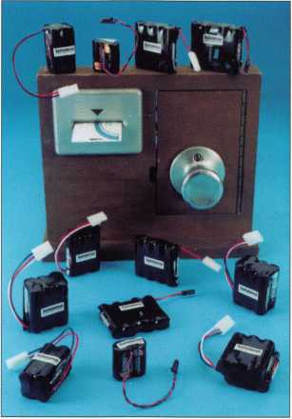

ranging from a single AA alkaline cell to six-cell lithium packs. Types in-stock include standard 6-volt and 9-volt packs for Saflok® and Ilco® door locks. In addition to standard door lock battery packs, Generation can design and build custom battery packs for virtually all applications, utilizing Duracell®, Eve ready®, Rayovac® and other power sources. Generation Door Lock Battery Packs are priced from $3.75 each (100 quantity) for a 4-cell alkaline pack.

Generation Electronics, Inc.

59 Technology Dr Lowell, MA 01851-2729 (800) 441-2833 (978) 453-6393 (978) 453-6470 fax [info@aved.com](mailto:info@aved.com) www. aved. com

Emhart Fastening Teknologies

Emhart has made significant updates to the POP-Matic® modular riveting system. The POP-Matic® modular riveting system eliminates the need for

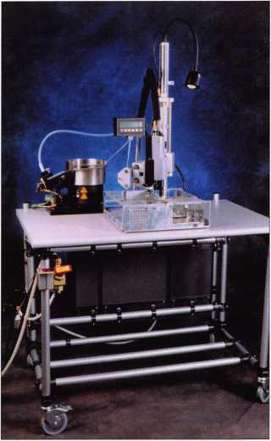

the operator to hand feed rivets to the setting head, which allows up to 40 rivets to be set per minute. Now the system incorporates the more compact setting head from Emhart s Point & Set® system. The setting head is now able to set rivets in tighter confines and is available as an in-line tool or as a fixtured unit on support arms. Emhart has also added an operator interface that allows the operator to program the unit to do the following: Count set rivets, Count parts completed based on the number of rivets set per part and Alert the operator when a rivet has been missed. Proven applications of this riveting system includes: Airbag assembly, Automobile vent systems, Computer chassis/electronic enclosures, Appliance assembly.

Emhart Fastening Teknologies

510 River Rd

Shelton, Conn 06484

(203) 925-3176

(800) 732-3116

www. emhart. com

January 2001

Keynotes **L_**

Applicants

For Membership



Dept

r *The following applicants are scheduled for clearance as members  
of ALOA. The names are published for member review and comment  
prior to February 1, 2001, respectively, to ensure applicants meet standards  
of ALOA’s Code of Ethics. Protests, if any, should be addressed to the  
Membership Department and must be signed.*

ARIZONA

Phoenix

Mike N Ramirez

CONNECTICUT

Greenwich

Christopher Bergin Sponsor: F.D. Reichert

Portland

William South

DISTRICT OF COLUIVIBIA

Washington

Paloma Conde SPONSOR: Javier Canovas

FLORIDA

Orlando

Robert Kowal Gregory Kowal

GEORGIA

Covington

Karen L Brown

Dublin

Christopher A Henry

Kennesaw

James E Frost SPONSOR: Ted D. Cheek

McDonough

Edmund D Tamburini

Savannah

Michael Schuman

ILLINOIS

Melrose Park

Joe E Battelli SPONSOR: Mike Gazippo

INDIANA

West Lafayette

Sandra F Amass

MASSACHUSETTS

Pittsfield

Michael F Morrissey SPONSOR: James Obrien

MARYLAND

Laurel

Stephen H Silvious

NORTH DAKOTA

Fargo

Chris J Sahr

SPONSOR: Todd Ladwig

NEVADA

Las Vegas

Donald E Hall SPONSOR: Ruben Romero

NEW YORK

Port Chester

Scott R Bierbaum SPONSOR: Paul Cordaro

OHIO

Cleveland

Frank J Murphy

SPONSOR: Jerome Andrews, CML

Columbus

Brian E Speaks

Vandalia

Michael J Kolb

SPONSOR: William M. Lockwood

PENNSYLVANIA

Chester Springs

Richard A Moses Jr SPONSOR: Brent Franklin

Erie

Joseph T Carneval SPONSOR: John J. Carneval

PR

Ponce

Iris W Rivera Cintron

RHODE ISLAND

West Kingston

Mark G Ingalls SPONSOR: Bill Young

SOUTH CAROLINA

Gray Court

Chris A Roberts

TENNESSEE

Kingsport

Chris L Shook SPONSOR: Fred McGuire

VIRGINIA

Alexandria

David E Alonso

Fernando G Alonso SPONSOR: Michael Groves

Manassas

Jeffrey N LeBlanc

University Of Richmond

Mark K Brooking

WASHINGTON

Kennewick

David L Peterson

JAPAN

Muroran Hokkaido

Morikazu Yamashita

YUGOSLAVIA

Belgrade/Zemun

Pavle Ristic

***Keynotes***

January 2001

Calendar advertising can generate revenue for a locksmith/security busi­ness. Advertising calendars can be your personal year-round sales representa­tive, working for you each and every day of the year in homes and offices. Hung prominently on the wall or sit­ting on a desk, calendars can display your Company name, promote the ser­vices you provide, and instantly show your phone number and address.

Calendars are A NECESSITY. Like clocks or watches, a calendar is a depended-upon-time piece, used many times daily. Your message is repeated several times every day in homes and offices where buying decisions are made. (Studies reveal that almost 98 percent of homes and nearly 100 per­cent of businesses use at least one paper calendar).

Calendars can be COST EFFEC­TIVE You control distribution. Every advertising dollar you invest is direct­ed toward the exact market you wish to reach. Long life (365 days) makes cost per impression a great value. The cost will probably be a small amount per day when you consider that you will receive a full year of advertising.

Calendars can be PERSONAL. A calendar says this is just for you. The recipient is personally involved as it becomes a working part of his / her daily routine to keep records, note appointments, jot down reminders, plan vacations, etc.

Calendars have GIFT VALUE. People will purchase calendars them­selves if they don’t receive one. With calendars, your advertising message is often welcomed in homes and offices.

Calendars are APPRECIATED. Calendars build goodwill, as they become a symbol of your company’s image. Your customers come to expect and look forward to getting your cal­endar each year.

Calendars have SALES POWER.

A calendar helps create a buying habit.

It is always there telling the customer who you are and how you can be reached. (One survey showed that 85 percent of all home calendar users do business with the firm that supplied their advertising calendar).

Although the end of November or beginning of December is the right time to send out calendars, it is not too early to consider, research and plan to use a calendar as a marketing tool for your business next year. Instead of sending a holiday card in December, why not consider a calendar - some­thing that has staying power the entire year.

Calendars are available in many styles and sizes. Standard as well as customized photos are available. (Per­haps a photo of your service vehicle!) Consider putting a home or office security tip on each page. Think of adding special customized messages, such as “Consider rekeying your home or office” or “Need a safe place for your records - call us for some valu­able ideas!”. Most have special envelopes to make mailing simple and cost effective.

Speak to an experienced promo­tional salesperson to find out what would work well when considering your company budget, timeframe, ad copy, logo, imprint color, target audi­ence, method of distribution, etc.

Why are calendars so popular? Calendars are regarded as a standard for a simple reason — people depend on them. Tie into this the fact that they can depend on you and your company to provide security solutions. That should be enough to make you consider calendar advertising as part of your next year’s marketing plan.

January **2001Keynotes I 13**

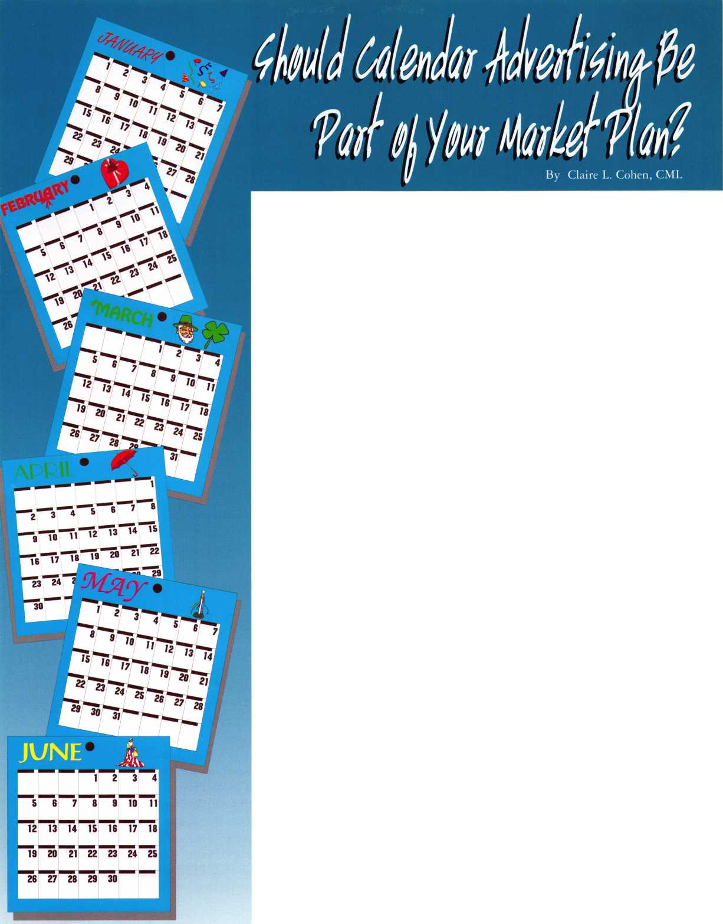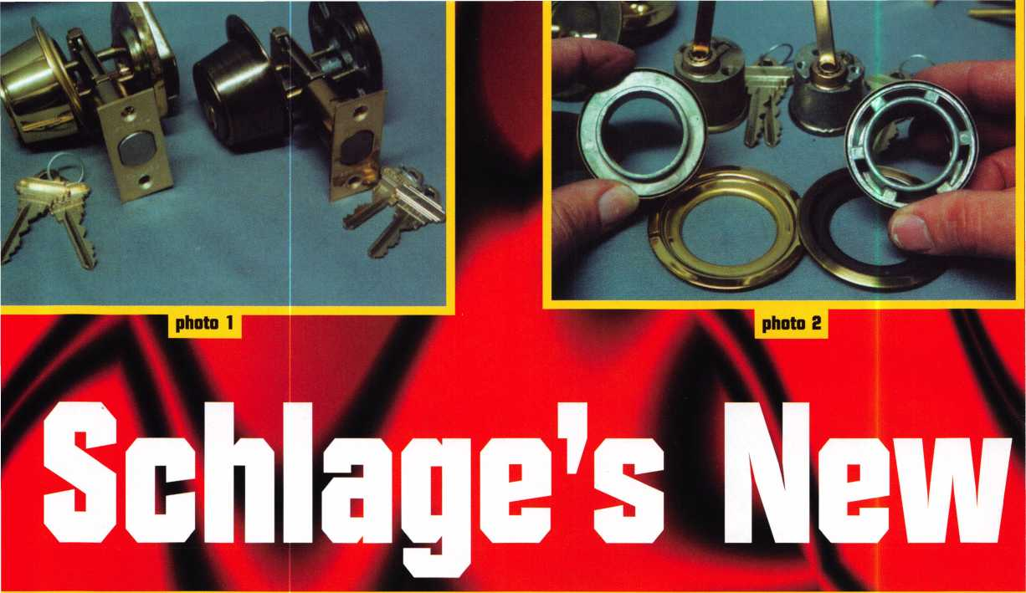

Schlage’s BC100 series of deadbolt locks will soon replace the B100 line. The B100 line has been Schlage’s standard duty residential deadbolt line.

The B160 is the single cylinder lock in the B100 line. The rest of the B100 line includes the double cylinder B162, and the thumb turn only (no outside cylinder) B180. Outwardly the new BC100 versions of Schlage deadbolt locks strongly resemble the older B100 line. Photograph 1 shows a BC160 deadbolt in polished brass (605 finish) on the left, and a B160 deadbolt in antique brass (609 finish) on the right.

If installed on a door, (beside the finishes) the only obvious difference would be the outward appearance of the thumb turns. The BC160 was originally introduced available only in polished brass (605) and dull chrome (626). By early 2001, the Schlage BC100 deadbolt line will be available in the following finishes: 609, 612, 613, and 625.

There are a number of changes/improvements in the BC100 line when compared to the B100 deadbolts. Most of the differences are not apparent after the lock is assembled, but can be seen when it is apart. Within the trim rings are cast metal inserts. Photograph 2 shows the solid insert for the BC160

on the left and the insert with some hollow spaces for the B160 on the right. By themselves, they allow for installation in a 1 1/2 inch diameter cross bore hole. Below each are the adaptor rings (unchanged) for installation in a 2 1/8 inch cross bore hole.

The most dramatic looking change is on the thumb turn side of the lock. The differences can be seen in photograph 3. The mounting screws that connect the inside and outside parts of the lock go through the actual thumb turn piece on the B160 (to the right). For the new BC160, the mounting screws must first go through a separate mounting plate (in the middle). The thumb turn piece (at the left) separately attaches to the mounting plate.

The method of assembly is not the only difference. The mounting screws are thicker and stronger on the BC160. They are 1/4 inch in diameter compared to 1/8 inch for the B160. The thickness of the mounting screws affects another part of the lock. The actual deadbolt piece that throws and locks into the door frame is affected by the size of the mounting screws. Photograph 4 shows a deadbolt for the BC160 lock in front and one for the

January 2001

**!** Keynotes

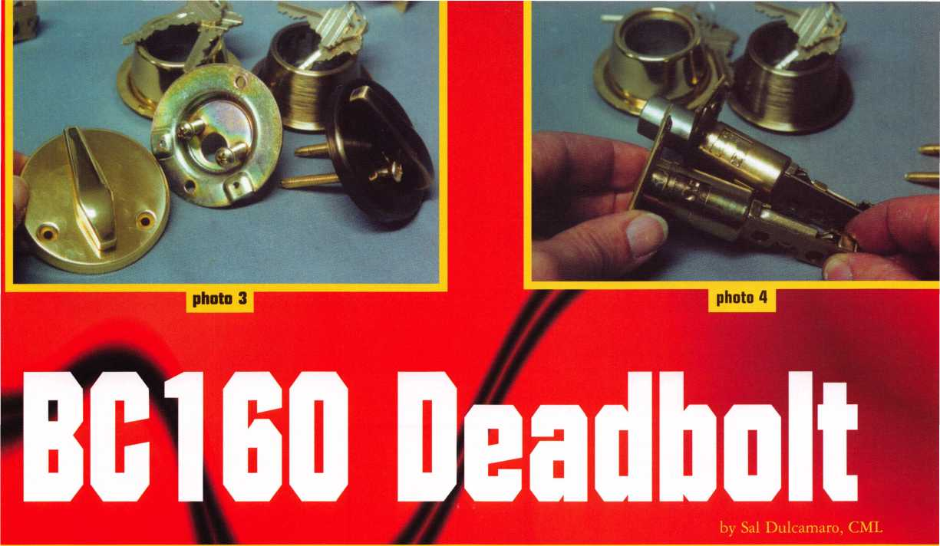

B160 behind it. The adjustment of the backset works the same for both deadbolts. You twist it and extend it, then twist back to set the backset, when going from 2 3/8 inch backset to 2 3/4 inch. The reverse would be done going from 2 3/4 to 2 3/8 inch backset.

The main difference between the deadbolts used in the BC160 and B160 can be seen in photograph S. The deadbolt for the BC160 is on the bottom and the other is just above it. The holes where the mounting screws pass through the deadbolt had to be enlarged to account for the thicker screws. The positioning was also slightly changed. The hole is not only wider, but also slightly elongated. The newer deadbolt latch, as a consequence, will work as a replacement for the one used in the older B160 locks, but not the reverse. You cannot use the old style latch with the new BC100 line locks.

The Cylinder Housing and Lock Cylinder

The Schlage B160 deadbolt lock came standard with a five pin lock cylinder. The new BC160 lock comes standard with a six pin lock cylinder. Photograph 6 shows the cylinder housing holding the

cylinder for the BC160 on the left and the housing for the B160 on the right. When the mounting screw diameter was doubled, the attaching location had to be moved up slightly, since the edge of the threaded hole was so close to the outside surface of the housing.

If you recall, I mentioned earlier the elongated holes in the deadbolt latch, through which the mounting screws pass. In order to make a new design deadbolt that would work with both the older B100 series locks and the newer BC100 series locks, Schlage had to account for mounting screws that were positioned slightly lower on one and slightly higher on the other. Along with the width of the hole, the elongated holes allowed one bolt to work for both designs. The BC100 deadbolt can be stocked as a replacement for both types. The deadbolts for the B100 series locks have holes that are both too small and too low to work with the BC100 line.

Let me get back to the lock cylinders and housings. The B160 lock came standard with a five pin lock cylinder. It was easily convertible by removing the screw that secured the cylinder in the

January 2001

Keynotes ***111***

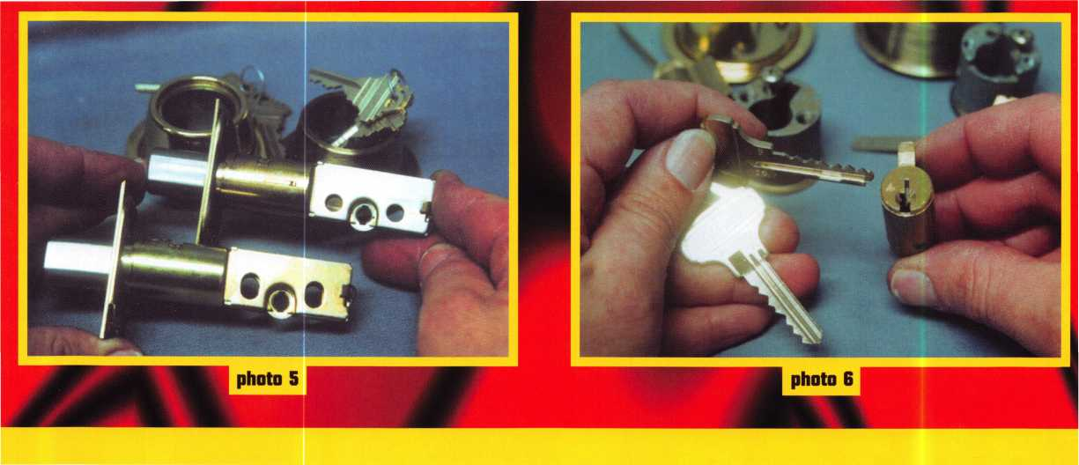

MLANJ 2001  
Annual Convention

March 29th thru April 2nd  
Somerset, New Jersey



For More Information:

PO Box 2441

Morristown, NJ 07962-2441  
Phone 973-267-8884  
Fax 973-538-2248

Or visit our web site at

[www.MLANJ.org](http://www.MLANJ.org)

January 2001

housing, and then replacing that cylinder with a six pin lock cylinder. The screw used is self tapping, so it only had to be reinserted into the other hole (on the left side of the cylinder, from the back view) and tightened with a screw driver. The BC160 lock cannot be used with a five pin cylinder, only a six pin cylinder. Photograph 7 shows both the BC160 and B160 housings with the cylinders removed.

The Schlage BC160 lock that I used, had a standard six pin “C” keyway cylinder. I was told that the BC160 and BC162 locks will be normally stocked with a Schlage Everest cylinder (all Everest cylinders are six pin). A sample Everest cylinder and keys are shown in photograph 8. A check pin in the cylinder plug is lifted by the raised surface near the tip of the key, next to the deep angled groove. Everest cylinders use somewhat restricted patented keys. The various standard commercial Everest



**J** Keynotes

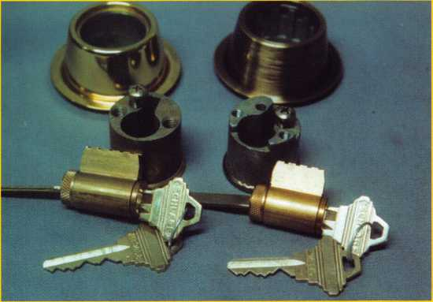

photo 8

keyway keys do not require signature cards or similar restrictions, but can only be duplicated by locksmiths (and some others) rather than the various retail key cutters. The more restricted Everest keyways are treated more like Primus keys for duplication.

The upgrades from the B100 line to the BC100 line of Schlage deadbolt locks, makes their lower priced deadbolts considerably stronger overall. Many locksmiths will still not consider those changes enough to consider it heavy duty or high security. If you need a Schlage product that more closely fits that description, you may want to consider trying the various locks in the B600 deadbolt line. Most locksmith supply companies will stock a majority of Schlage s lock products, and you may be able to find out additional information from them. You can call Schlage toll free at: 800/847-1864 or visit their web site [www.schlagelock.com](http://www.schlagelock.com).



**Let’s**

get ,

**personal.**

*We built our reputation on personalized service. Call us, well tell you all about it.*



**Stone & Berg**

***Wholesale Locksmith Supply Company***

(800) 225-7405 • Fax: (800) 535-5625

24hr.Toll-Free

January 2001

Keynotes

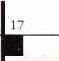

Keynotes

NEEDS YOUR HELP!!!

Authors Wanted

Share your Knowledge and experience with others in  
the field by writing both technical and non-technical

features for upcoming issues of Keynotes*

We will send you $$$$$$ for your contribution!*

For more information on Editorial Guidelines

Payment Criteria contact Patanya

Managing Editor at

send an e-mail

Keynotes

3003 Live Oak Street

Dallas, TX 75204

(214)827-1701

(214)827-1810 fax

*Amount is based on length of text and

photos included

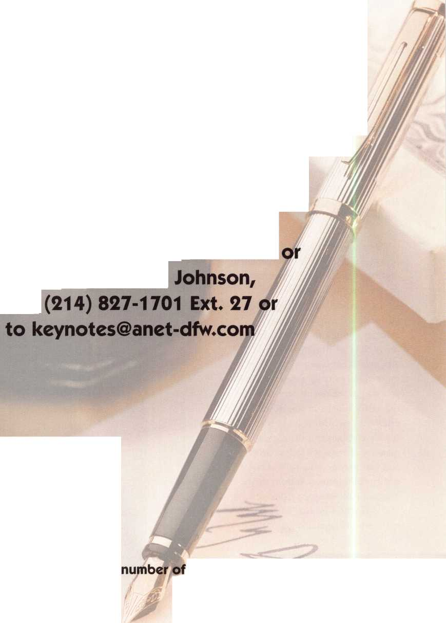

by Sal Dulcamaro, CML

Many locksmiths would like to be able to sell the heavy duty, higher quality and more expensive locks and security devices to all of their customers. It is a task that is easier said than done. Even the most persuasive locksmiths and security professionals still run into the customer who just wants a very inexpensive lock and absolutely nothing more. Your choices, then, are to lose the sale or stock some lower priced locks for just those kinds of customers. When it comes to buying power, we all know the huge advantage that the super-mega hardware stores have. In many cases we can’t even find a lock at wholesale for the prices they are charging as retail. I recently ran into a supplier of lower priced imported residential door hardware that may help (at least a little bit) to level the playing field for locks in that category.

Brass & Brass, a Torch Trading Company, has an interesting assortment of lower priced residential locks. Most of the locks under that brand name are grade 3, but they do have some door hardware available in grade 2. The Brass & Brass product line includes a variety of tubular key-in-knob and key-in-lever locksets (also knob and lever hardware in passage and privacy functions). There are also rim and tubular deadbolts. Brass & Brass also has some keyed locksets in grade 2, although I didn’t see those products.

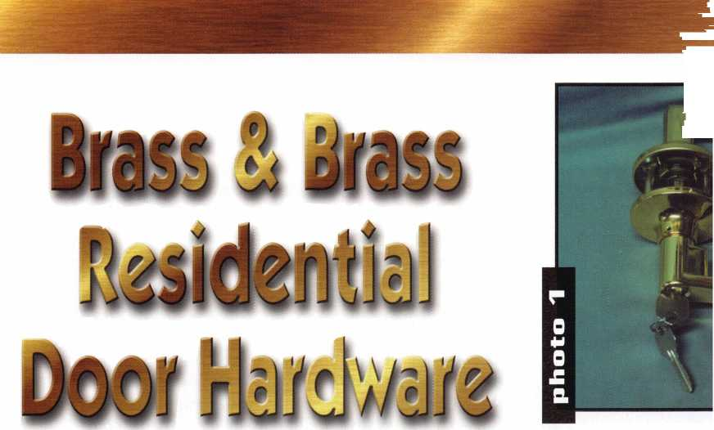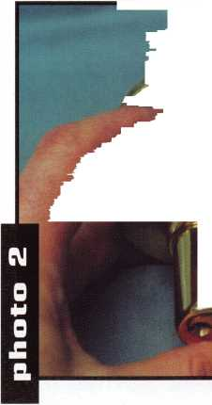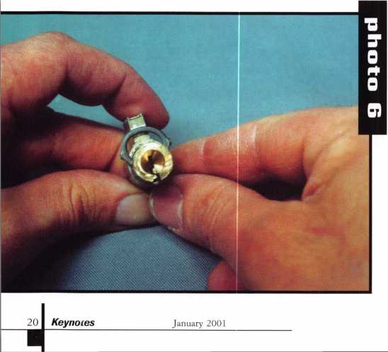

Tubular Key-in-Lever Locksets

Photograph 1 shows two different style tubular key-in-lever locks. The plain lever on the left is essentially not handed since the key way is sideways, and it looks pret­ty much the same on a left or right handed door. The fancier scrolled pattern of the lever handles for the lock on the right would require that you order the correct handing of the locks to match the doors.

Both of the lever handle locksets are disassembled and serviced the same way. The plain lever handle lock is shown in photograph 2, with the retainer access hole in the approximate position of the small hand of a clock at about 10:30. As is typically the case for keyed locksets, when the retainer access hole is not positioned at 3 o’clock or 9 o’clock, the handle will have to be rotated to position the retainer in line with the access hole.

Photograph 3 shows the lever handle rotated to line up the retainer with the access hole. A poke tool can be used to push in the retainer through the access hole, and the lever handle can be pulled off the lock. Unlike some imported locks of a similar design, the cylinder plug does not have to be rotated first to activate the retainer. Therefore, picking or having an operating key is not necessary to remove the lock handle.

With the lever handle off in photograph 4, you can see the back end of the lock cylinder inside of it. The cap, that fits over the back of the plug, has an open slot that actuates the locking mechanism when the key is turned in the lock cylinder. A pressed-in small white plastic part

**photo 7**

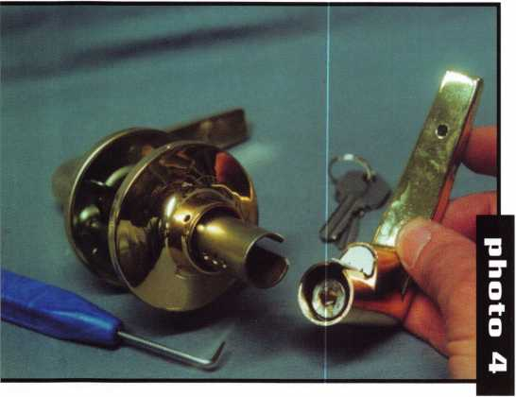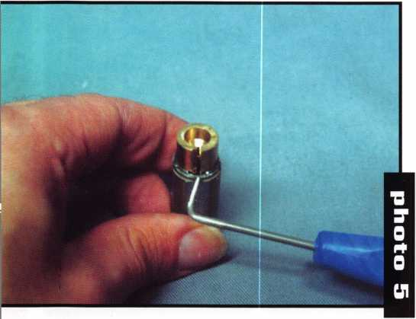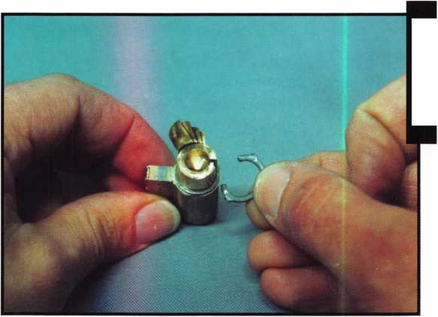

**photo**



holds the cylinder inside the lever handle, much like many other residential and commercial key-in-lever locksets.

After removing the lock cylinder from inside the lever handle, the cap (at the end of the cylinder plug) must be removed before the plug can be removed from the shell and serviced. With the cap removed, in photograph 5, it is possible to get a clear view of the plug retainer clip. The tip of the poke tool points to the gap between the two ends of the “C” clip that retains the plug in the shell. The two ends of the clip happen to be fairly close together, and that will affect the ease of removing the clip and servicing the lock cylinder. In this case, it will take more than just sliding off the clip. The ends will have to be slightly spread apart to remove the clip.

Photograph 6 shows a back view of the lock cylinder with the clip partially pried off the plug. The process of spreading apart the clip has altered the shape from basically circular to almost an oval shape. With the clip completely removed, in photograph 7, you get a slightly better view of the reshaped clip. If you look at the back of the lock cylinder, you may notice that there are a few pieces of shim stock protruding from the gap between the plug and the shell. There are four pieces of shim stock stacked on top of each other, and I could actually squeeze in a fifth piece. At 1.5 thousandths of an inch thick, there is a gap of at least 7.5 thousandths of an inch between the plugs and shells of the lock cylinders I found in the various Brass & Brass locks. For many commercial locks, that is one half of a full increment between depths. I only point that out to let you know that these are not precisely

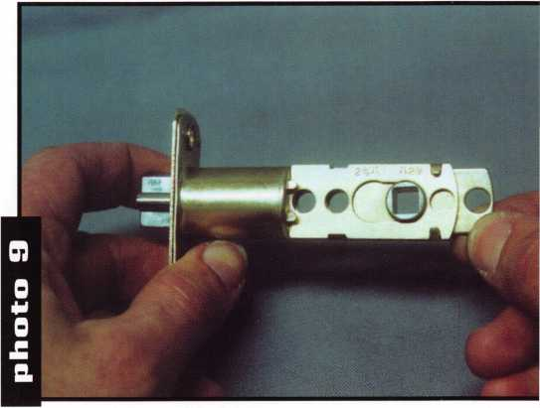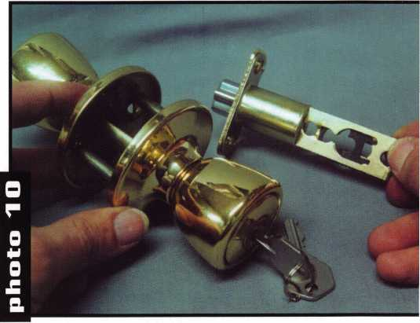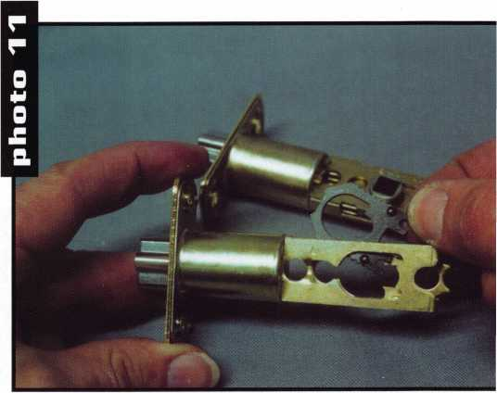

January 2001

Keynotes

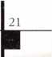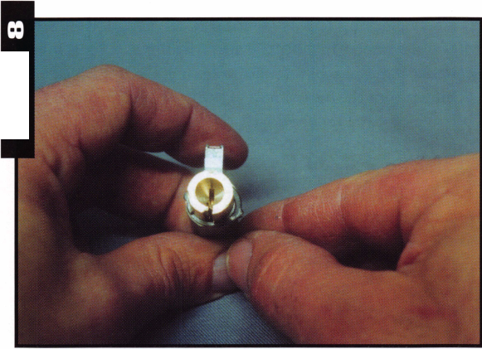

manufactured, and that there are many applications where you would probably never use locks with such imprecise tolerances. When someone wishes to buy extremely inexpensive locks, they should realize that precision costs money. If cost is the only concern, though, these can easily fill the bill.

The “C” clip has been re-installed as shown in photograph 8. Notice that the stretched clip looks too big to act as a retainer now. Like a number of other locks I have seen over the years, it will be necessary to squeeze the clip together (with pliers or some other tool) to regain the original shape and securely retain the plug.

Photograph 9 shows the adjustable latch that is used with the key-in-lever locks. It is very easy to change the backset of the latch. You only have to pull out or push in the end piece of the latch, and it can be either 2 3/8 or 2 3/4 inch backset. The actuating piece in the lock is square, as is the opening in the latch. There is no handing to change for the locks. The plain levers are non-handed, and the decorative levers are effectively permanent left or right hand.

Faux Kwikset

A Brass & Brass look alike version of the Kwikset 400 series residential knob is shown in photograph 10. Although I didn’t mention it earlier, all the Brass & Brass locks have keyways compatible with Kwikset. The spacing and depths also seem to match. The knob lock comes standard with an adjustable backset latch. Photograph 11 shows the piece being removed that converts the latch from 2 3/8 to 2 3/4 inch backset.

Servicing this lock is identical to servicing a Kwikset 400 series knob. In photograph 12, I’m using a Kwikset cylinder removal tool to remove the Brass & Brass lock cylinder from the outer knob. Photograph 1 3 shows a back view of the removed lock cylinder. It appears to be nearly identical to the Kwikset version. It even uses reversible bottom pins very much like the pins used in Kwikset locks. Unlike the lever handle locks, this uses the more standard style “C” clips, and is as easy to remove as the Kwikset one. The gap between the plug and shell for the cylinder in this lock was just as large as the one in the lever handle lock. The cost is about half that of the Kwikset original.



Keynotes

January 2001

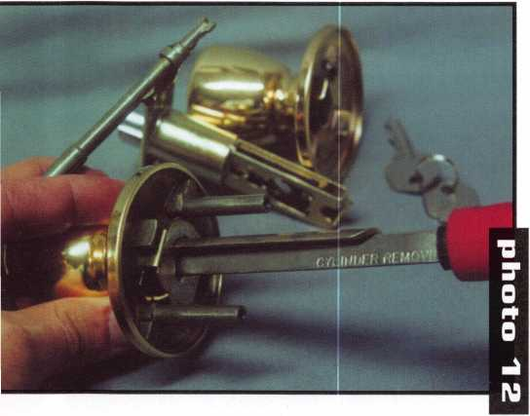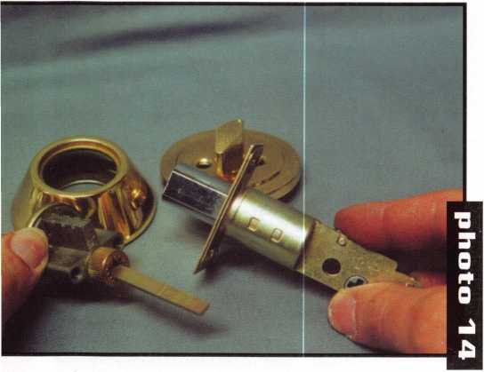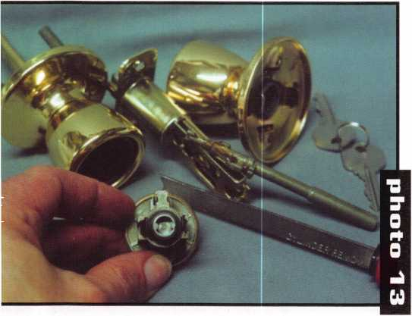

Other Brass & Brass Locks

Photograph 14 shows a Brass & Brass deadbolt lock. It also has an adjustable backset deadbolt mechanism. It is fairly light weight with a mostly hollow outer trim ring. It is also fairly low priced. I didn’t have the opportunity to look at or disassemble any other Brass & Brass locksets, but I saw a variety of other types in their catalog. Their tubular key-in-knob lock seems to be constructed similar to the key-in-lever locksets (except for the handle shape).

They are, I presume, hand changeable in the field.

Although the catalog didn’t make it entirely clear, there seem to be grade 2 cylindrical key-in-knob and key-in-lever locks available. Residential handlesets with a lifetime finish guarantee were identified in the catalog. The price of $69-95 didn’t seem extremely cheap, however, in comparison to brand name locks with a similar guarantee, it might be relatively inexpensive. The locks overall are not bad looking and appear to be of decent quality for locks in such a low price range. One of their flyers indicated an “unconditional replacement guarantee.” I’m not quite sure what that entails or if it applies to all their products.

If you have the need to find a low priced line of locks to fill a particular niche, you may want to consider Brass & Brass. For additional information, call: 800/596-7364.

MasterLink Security Products

ROGER ALEXANDER-TUTTLE  
“...understanding the needs of locksmiths...”

Mortise/Rim/Knob Cylinders • Storefront Door Hardware  
Cabinet Locks • Chain • Key Blanks • Padlocks • Pins ...and more

Local: (954) 730.9669 • Toll Free: (877) 347.9669

Fax: (954) 486.0575

e-mail: [masterlink@mindspring.com](mailto:masterlink@mindspring.com)

3863 NW 19th Street, Lauderdale Lakes, FL 33311

It's True

Marray has developed the first  
screwless door loop.

Aluminum ma-  
terial means  
true anodizing.

No off color  
powder coat-  
ing or painting

Screwless base and cap means you drill two 1/2 inch diameter holes, pop the base into the hole, wire your system and snap on your covers. Simple as 1, 2, 3.

Here’s the best part We are giving awav a

FREE SAMPLE TO THE FIRST 1 OO CALLERS WHO MEN-  
TION THIS ADD. A $14.40 WHOLESALE PRICE VALUE.

CALL TODAY, IT’S FREE!!

1-800-500-1449

Marray *enterprises, inc.*

At Marray, we’re not just modifiers, we’re Master Hardware Modifiers™  
1128 Walsh Ave., Santa Clara, CA 95050. [www.marray.com](http://www.marray.com)

January 2001 Keynotes

Standard 18” length. Can be ordered in cus­tom lengths

Plastic base stops shorts and pro­tects wires

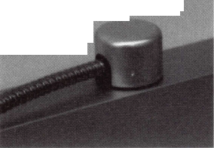

Last year, the ALOA Scholarship Foundation awarded 25 full  
package scholarships to ALOA 2000 in Las Vegas, Nevada. Of the  
25 awarded 21 recipients accepted and took advantage immediately

by attending the classes offered in Las Vegas. Ask any one of those  
recipients and they’ll tell you how the scholarship was beneficial in  
gaining knowledge for the improvement and development in the field.

The Scholarship Foundation worked hard at ALOA 2000 and will continue to work throughout this year to raise funds for future awards.

Don’t get left out this year. ALOA 2001 in Baltimore will provide more educational and career opportunities for locksmiths and others in the security industry. Take the time and complete the scholarship application at the right.

You can take advantage of one of our associations most valued resources and learn more about the trade. Who knows, you could be one of the next recipients. The ALOA Scholarship Foundation is waiting to hear from you.

TEXAS LOCKSMITH ASSOCIATION

***Annual Convention & Trade Show***

February 6-11, 2001  
Omni Austin Hotel Southpark  
Austin, Texas

For Information:

Judy Clifford @ 297-2413 Email: [clifford@tgn.net](mailto:clifford@tgn.net) Jim Hetchler @830-606-1727 See Website @ <http://tla.tsx.org> Tollfree: 1-877-TLA-INFO

Featuring:

A.L.O.A. Ace classes Free Clinics & Seminars Exhibits

Annual Party & Awards Ceremony PRP Testing by A.L.O.A.

A CAPITAL INVESTMENT IN YOUR FUTURE!

Keynotes

January 2001

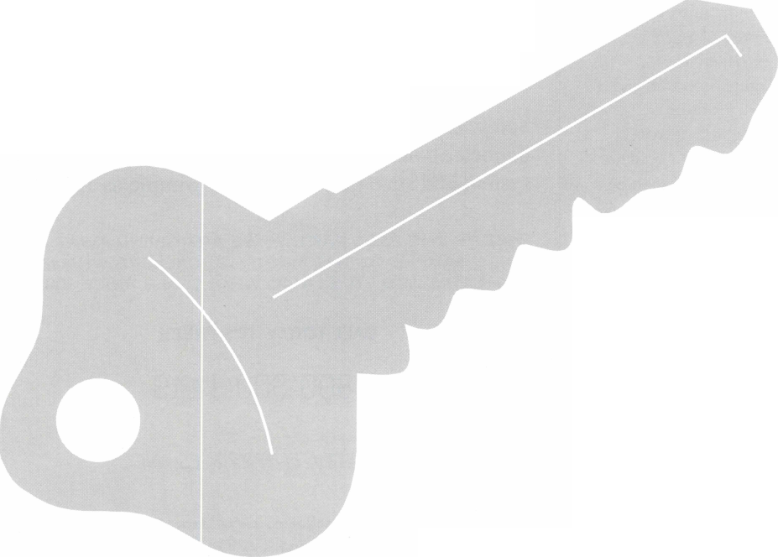

**ALOA Scholarship Foundation, Inc.  
Scholarship Application**

3003 Live Oak Street; Dallas TX 75204  
(214) 827-1701, (800) 532-2562

Please print or type **Name**

**Home Address . Home Phone**

PRP/STPRP **Level . City**

ALOA/SAVTA#.

**State Zip**

**Dob**

**Educational Level .**

**(years) Degree, IfAny_**

**Present Employer .**

**Work Address**

**Work Phone**

**Position**

**Supervisor’s Full Name . City**

**State**

**Zip .**

**Fax**

**Full Time**

**Part Time**

**Take Home Pay**

**Length Of Time In Locksmithing**

**Marital Status Number Of Dependents Classes Desired**

**Membership In Trade Associations (List By Name)**

**Household Annual Gross Income**

**Date Of Classes .**

**Organization Sponsoring Classes:** ALGA _

SAVTA.

**Other**

**Location**

Applications will be reviewed by the ASF Selection Committee on an objective and nondiscriminatory basis. All materials and information pertaining to the applicant’s financial status and background shall be held in strict confidence by the Selec­tion Committee.

ALOA Scholarships are granted to selected individuals desirous of entering the locksmithing field or to selected individuals already in the locksmithing field who wish to improve their professional skills through education.

Applications for classes must be received 60 days prior to the date of the class, and will be reviewed as they are submitted. Scholarships for classes at the ALOA or SAVTA convention will be awarded each year at the ALOA Scholarship Foundation meeting preceding the convention and must be received by March 1 each year.

Please attach to this form a letter stating your reason for applying for a scholarship, what you plan to do with the knowledge you obtain and any other information you feel may be helpful to the scholarship board in making its decision. In addition, attach three letters of reference from individuals who have personal knowledge of your background and character. The letters should contain their names, addresses and phone numbers. It would be helpful if at least one of these references is an ALOA or SAVTA member. All scholarship recipients will be required to provide a 3” x 5” photograph of themselves.

**Application Checklist**

Only complete applications will be considered for scholarships. An application is considered incomplete unless ALL of the above requested information is received before the deadline: 60 days prior to the classes desired, March 1 for ALOA/SAVTA convention classes. Please send this application after checking off each of the below.

* I have filled in each blank on this form.
* I have written and enclosed a letter explaining my reason for applying.
* I have enclosed three letters of reference.
* I am submitting this in time to be received 60 days prior to the date of a class or by March 1 for ALOA/SAVTA convention classes.
* I have enclosed a 3” x 5” photograph.

**Certification Of Applicant**

I certify that the information contained herein, and all supplemental forms are complete and correct to the best of my knowledge. I further certify that if I am selected as a scholarship recipient I will use the knowledge gained for the improvement, development and advancement of the lock­smithing profession. Also, if asked by an authorized ASF official, I agree to give proof of the information that I have given on this application. I also understand that this proof my include copies of my previous year’s Federal Tax Return. I also understand that if no proof is given when request­ed, I may not receive consideration for an ALOA Scholarship Award. I understand that this application is valid only for the event/class specified.

SignatureDate

Please send all completed applications to:

ALOA Scholarship Foundation, Inc. • 3003 Live Oak Street • Dallas, TX 75204

Revised 12/00

Keynotes

January 2001

By Bob Cronk

Do you hear an “Opportunity for Profits”, when the callers say: “Can you come over and fix our doors? The locks wont work, and the hinges are letting our doors sag and drag on the thresholds.”

Medium and high-traffic doors often show wear because the frequent usage and stresses are more than many traditional hinges can handle. A sagging door condition is most commonly caused when the top butt hinge or pivot has started to pull out from the frame. One way to remedy this condition is to install a full- length continuous geared hinge that distributes the door weight and stresses over the full length of the door and frame. The door can usually be salvaged, and the locksmith becomes a hero to the customer. Best of all, this is a Profit Opportunity for the savvy locksmith!

Continuous geared hinges are utilized as a hinging system for aluminum, wood, and hollow metal door and frame applications, both for retrofit and new construction. This commercial architectural hardware product is being specified more and more for medium- to-high traffic interior and exterior doors. Continuous geared hinges are well suited to keeping entrance components in alignment while withstanding the pressure of many thousands of cycles per year and, in some cases, even thousands per day! High winds also take their toll of door hardware systems.

The continuous geared hinge provides clean, eye-appealing design lines and can be anodized or custom painted to match nearly any exterior design. Constructed of three interlocking, anodized extrusions (two geared leaves and a cover channel), a continuous geared hinge installs on the full length of the door and frame, uniformly distributing the opening and closing force of the door. The vertical door loads are carried on a series of either high-tech plastic or steel bearings

along the full length of the hinge. Continuous geared hinges can be manufactured in light duty, standard duty, heavy duty, or extra-heavy duty versions. The heavy and extra-heavy duty models have additional bearings and fasteners to support added door weight, extra-wide doors, lead-lined doors, or any doorway having unusually frequent traffic.

This full-length design seals the gap between door and frame, offering security, privacy, noise reduction, weatherproofing, and no-finger-pinching features. Continuous geared hinges also reduce or eliminate the recurring problem of wind damage caused to doors by attempts at closing the door while a broomstick or other foreign object has been wedged into the gap between door and frame. The disbursement of opening force along the length of the door also greatly reduces the amount of stress on a door caused by misaligned butt hinges or pivots, which by their nature localize door weight and stress at the upper portion of the door. Most importantly, continuous geared hinges serve to reduce or eliminate door sag.

Continuous geared hinges are installed on the surface of the door and frame. No costly mortising or cutouts are required on either the door or the frame. When the door is closed, most profiles have no exposed screws, bolts, pins or knuckles to be vandalized.

There are three main applications for continuous geared hinges:

Full Surface Mounting

Full surface continuous geared hinges are installed on the face of a door and frame. This profile is usually used in retrofit situations, but can also be used with new doors and frames. The hinge is installed with

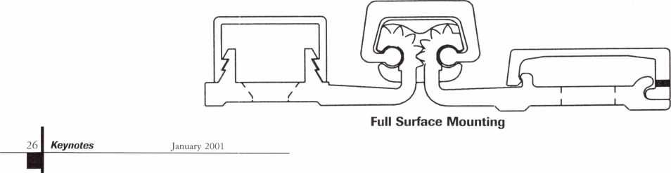

Half-Surface Mounting

Concealed Mounting

Instead of being “mortised,” the  
concealed type of continuous geared hinge  
is simply mounted on the hinge stile of the  
door and on the rabbet of the frame. This  
profile is normally specified for use in new  
construction, but can also be used with  
new doors in existing frames.

12-24 fasteners in the frame  
leaf, and fastened with  
through-bolts and °-20  
shoulder screws through  
the door.

Full surface hinges are also  
usually designed with four  
locator holes per hinge. The  
design is to aid in the  
adjustment of fitting the  
door plumb and square in  
the entrance opening before  
installation of the door and  
frame fasteners. This profile  
can be used on aluminum,  
wood and hollow metal  
doors up to 2 °-inch thick.

A common use for full surface hinges is on doors  
that have sagged due to damage or wear on the  
original butt hinge or pivot.

Half-Surface Mounting

Half-surface continuous geared hinges are installed  
on the face of a door, with the frame leaf concealed.  
This profile is usually used in retrofit situations, but  
can also be used with new doors and frames. The new  
door must be undersized by the amount of clearance  
needed at the lock side of the door, plus 3/16-inch  
(1 /8-inch frame leaf + 1/16-inch clearance = 3/16-  
inch) on the hinge side. The frame leaf is installed on  
the rabbet of the frame with 12-24 fasteners, and the  
door leaf is through-bolted to the door surface with  
hexnuts and °-20 shoulder screws. This profile can be  
used on aluminum, wood and hollow metal doors up  
to 2 °-inch thick. A common use for half-surface  
hinges is on doors that have been weakened at the  
hinge edge, but the door itself is still serviceable.

/

/

\

\

/

✓



* A new square-edge door must be undersized by the amount of clearance needed at the lockside, plus 5/16-inch for the hinge (1/8-inch leaf +

1/8-inch leaf + 1/16-inch clearance between leaves = 5/16-inch).

* A new bevel-edge door must be undersized by the amount of clearance needed at the lockside, plus 11/32-inch for the hinge (1/8-inch leaf +

1/8-inch leaf + 3/32-inch clearance between leaves = 11/32-inch).

The hinge cap on the profile requires a 7/16-inch  
rotational clearance at the

jamb side. The hinge opens  
to a full 180 degrees, and is  
usually designed for either  
1 ae-inch or 2-inch doors.

The concealed hinge is  
engineered to work with a  
closer having a butt hinge  
type pivot point. Existing  
concealed floor or concealed  
overhead closers having a  
fixed center pivot point must  
be replaced with a traditional  
overhead surface closer.



Concealed continuous  
geared hinges are normally  
installed with either 10-24 or  
12-24 undercut head, thread-  
forming fasteners. A pilot  
hole needs to be drilled, and  
the fastener then forms its  
own threads. Some installers  
use self-drilling fasteners, but  
they are not recommended  
for installation in mortar or

|  |  |  |
| --- | --- | --- |
| / |  | s |
| / |  | V |
|  |  | / |
| \ |  | / |
| / |  | s |
| / |  | \ |
| s |  | / |
| \ |  | / |
|  |  |  |

Concealed Mounting

l

January 2001

Keynotes

grout-filled door frames. The drill point in all proba­bility will hit the mortar and create a “jacking effect” on the frame. It is recommended to first remove the mortar with a masonry bit. If possible with contract work, some form of mortar guard should be specified behind slushed-in frames. Security fasteners, wood screws and other fasteners are also available for certain applications.

Evolution

Like many product lines, design improvements have taken place since the concept of continuous geared hinges was first introduced over 25 years ago. Modern continuous geared hinges have templated hole patterns, lubricated bearings, permanent lubri­cants on the geared areas (which nearly eliminates maintenance needs), extended wear life, non-handed design, 410 stainless steel fasteners, security features, electrical modifications, and decorative hinge caps.

Continuous geared hinges are manufactured in standard industry lengths (79, 83, 85, 95 and 119-inches) that allow for threshold clearance in

most openings. Mounted flush with the top of the door and allowing 1/8-inch header clearance, standard length hinges allow 7/8-inch clearances at the bottom. Hinges can be cut to exact lengths in the field, or at the factory. After cutting, a non-handed new continuous hinge may become handed, depending on the model. Most hinges are finished in 628 Clear anodized aluminum, or Dark Bronze anodized colors. Custom anodizing and custom painting allow the hinges to be matched with other hardware finishes.

A properly installed continuous geared hinge can easily last ten to twenty years or longer in an entrance, and tolerate a great deal of abuse and heavy traffic with little or no maintenance required.

Schools, hospitals, public buildings, hotels, airports, sports centers, hospitals, storefronts and wastewater treatment plants are just a few of the many commercial, governmental and industrial facilities that are specifying continuous geared hinges because they extend the life of the entrance system.

We only make continuous gear hinges, and we've become very, very good at it!

Here's why.. . Our founding strategy was simple. Provide  
the highest quality product and service at a reasonable price. Striving to achieve  
this goal has made us industry leaders and innovators. SELECT was FIRST to:

* Anodize clear hinges after machining = last longer
* Offer templated, logical hole pattern hinges
* Offer Quick Shipments - 48 hours or less on most orders
* Provide single hinge packaging with fasteners included
* Create an 85" standard length continuous gear hinge
* Provide 410 SS plated and hardened fasteners
* Offer full-surface swing clear hinge with replaceable covers

TRUST AN INDUSTRY LEADER.

Designed for today; Geared for tomorrow...

[www.select-hinges.com](http://www.select-hinges.com)

**SELECT PRODUCTS LIMITED**

9770 SHAVER RD • PORTAGE, MI 49024  
800-423-1174 • FAX 800-423-7107

z

Keynotes

January 2001

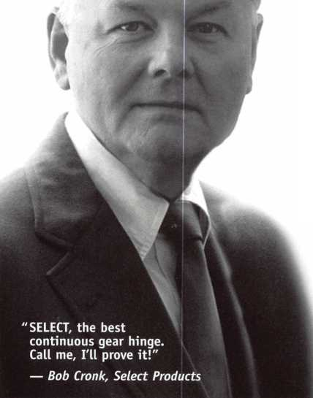

I

**BOARD**

nominations

**What ALOA Board  
Positions Are Open  
and Where Am I  
Qualified  
to Run?**

There are currently six regional direc-  
tor positions open for election in addition  
to the position of President. ALOA mem-  
bers now elect the directors from their  
own regions. Only ALOA members from  
a region are eligible to run for the open  
position(s) in that region. And only mem-  
bers from the nominee's region wi II be  
receiving a ballot to vote for that candi-  
date. Members from any region are eli-  
gible to run for the President's position.  
You must have been an ALOA member  
for at least three years to run.

The following vacancies will exist for  
the election to be held before the ALOA  
2001 Convention:

**Southeast two directors  
North Central two directors  
Southwest two directors  
President**

If you have any questions,  
please contact Charles Gibson at (800)  
532-2562 or email [charlie@aloa.org](mailto:charlie@aloa.org)

On this page you will find  
the required nomination petition  
and on the following page, the nomina-  
tion form.

The following is the number of signa-  
tures required for each Board position:

**President 25**

**Southeast Director 12**

**North Central Director 14**

**Southwest Director 13**

Associated Locksmiths of America, Inc. **Board of Directors Nomination Petition**

Please print legibly or type. This form can be reproduced if needed.

|  |  |  |  |
| --- | --- | --- | --- |
| 1, the undersigned, request that |  |  | be olaced on |
| (name of nominee and member number)  the ballot for for the election to be held at  (position for which individual is being nominated)  the special meeting of ALOA members to be held in 2001 or any adjournment thereof.  1 am eliaible to vote in the reaion. | | | |
| i |  |  |  |
| PRINTED NAME  2 - -- | MEMBER# |  | SIGNATURE |
| PRINTED NAME  3 | MEMBER # |  | SIGNATURE |
| PRINTED NAME  4 | MEMBER# |  | SIGNATURE |
| PRINTED NAME  5 | MEMBER # |  | SIGNATURE |
| PRINTED NAME  6 | MEMBER# |  | SIGNATURE |
| PRINTED NAME  7 | MEMBER # |  | SIGNATURE |
| PRINTED NAME  8 | MEMBER# |  | SIGNATURE |
| PRINTED NAME  9 | MEMBER# |  | SIGNATURE |
| PRINTED NAME  10 | MEMBER# |  | SIGNATURE |
| PRINTED NAME  11 | MEMBER# |  | SIGNATURE |
| PRINTED NAME  12 | MEMBER# |  | SIGNATURE |
| PRINTED NAME  13 | MEMBER # |  | SIGNATURE |
| PRINTED NAME  14 | MEMBER# |  | SIGNATURE |
| PRINTED NAME  15 | MEMBER# |  | SIGNATURE |
| PRINTED NAME  16 | MEMBER# |  | SIGNATURE |
| PRINTED NAME  17 | MEMBER# |  | SIGNATURE |
| PRINTED NAME  18 | MEMBER# |  | SIGNATURE |
| PRINTED NAME  19 | MEMBER# |  | SIGNATURE |
| PRINTED NAME  20 | MEMBER# |  | SIGNATURE |
| PRINTED NAME  21 | MEMBER# |  | SIGNATURE |
| PRINTED NAME  22 | MEMBER# |  | SIGNATURE |
| PRINTED NAME  23 | MEMBER# |  | SIGNATURE |
| PRINTED NAME  24 | MEMBER# |  | SIGNATURE |
| PRINTED NAME  25 | MEMBER# |  | SIGNATURE |
| PRINTED NAME | MEMBER# |  | SIGNATURE |

January 2001

***Keynotes***

YOUR COMMITMENT TO ALOA BOARD SERVICE

(Please read carefully and sign where indicated.)

The responsibilities of an ALOA board member include contributing a moderate amount of personal time, and a significant degree of professional guidance and expertise to the organization.

You will be expected to come to board meetings and the annual membership meeting. You will need to be prepared to sensibly discuss matters of great importance to your profession and participate in setting policy as part of a governing body. Your course of action during your tenure on the ALOA board should be guided by fair minded, constructive goals pertaining to matters of consequence for ALOA and for the industry. Your contributions are expected to benefit ALOA as a whole, taking individual member rights and concerns into account, but free of the taint of partisan politics or personal gain.

On a practical note: ALOA board members are expected to behave and dress professionally at all times, especially when actively representing the association. ALOA board members are required to participate in two board meetings per year, of three or four days in length, one each fall and spring. Board members are also asked to attend the annual convention and are required to attend the annual membership meeting. Board members may also be asked on a voluntary basis, to represent ALOA at related local, state or regional functions, including serving in the ALOA Booth and otherwise promoting ALOA. When travel is required for a board member, expenses covered by ALOA include lodging, travel and a reasonable **per diem.** The Board has stipulated that assigned travel will be reimbursed at the lesser of the 30-day advance tourist class airfare in effect at the time of travel or the current per-mile rate for travel by personal automobile. Spouse expenses, including extra room charges, etc., are the individual's responsibility.

• • •

I have read and understand the above responsibilities of an ALOA board member, and agree to commit my time and energies as needed. I certify all of the information contained on this form and supporting documentation to be true and complete.

I can be contacted with questions at:

Address Phone #

Signed:

Date

Please attach a recent photograph of yourself and retain a copy of this profile for your own files. This profile and all supporting documentation should be submitted no later than March 31, 2001.

Mail to:

Nominee Profile

Secretary of the Board of Directors  
Associated Locksmiths of America  
3003 Live Oak Street  
Dallas, TX 75204-8186

REV. 11/00

***Keynotes***

January 2001

Haw To Manage

*ounger Workers*

y By Joseph Arkin

Each year businesses provide thousands of jobs for young people. From one perspective, those companies benefit from the vitality inherent in youthful eagerness. When trained and supervised, younger workers can make a valuable contribution to a business. They typically have sharp eyes, quick fingers and a desire to employ their youthful energy.

However, from another perspective, business managers need to understand the problems often connected with the employ­ment of younger workers. That includes a measure of understand­ing different perspectives that distinguish younger workers from older generations.

Naturally, younger workers become products of their environment. In recent decades, the changes in technology have separated them from those reluctant to adapt to a changing world. From a different perspec­tive, many children with two working parents have been raised by strangers.

As a result, some younger workers lack the traditional “work ethic.” Fun and games remain more attractive than

working. At the same time, authority figures have less influence than previously. Disrespect for authority is becoming more prevalent.

That suggests that some constructive counseling can start young workers off right.

A continuing effort can help keep them on the path that makes them productive, profitable employees.

That counseling begins with understanding the change in sta­tus a young person encounters when he goes to work. He is moving from a world where he enjoys status with his peers, perhaps a member of an athletic team or as a member of a social or service organization. So, try to make the young worker feel that he is a part of your team, even though his job initially may focus on relatively menial tasks.

Start the process with an introduction to fellow workers. Don’t assume that a young worker has the social skills necessary to become a part of the employee group alone. Help alleviate his apprehension.

The counseling can be more complicated than it first appears.

After all, most business managers are also parents. They tend to focus on familiar factors that sometimes prevent the young from naturally being good workers. They overlook the fact that each child is different. Each has his own growth rate, attitudes and interests. Those differences deserve special attention.

As a start, recognize the inherent contradictions you will find with many young workers. They are anxious to become adults, yet they are often slow to give up their childish ways. They want freedom, yet they often lack the necessary sense of responsibility to use that freedom productively.



January 2001

Keynotes

Discipline remains a foreign concept to many young workers. They may or may not follow orders. In either event, they often question a managers instructions. An employer should exercise restraint when responding to youthful responses. Harsh responses can make a young worker defensive or rebellious. A potentially productive employee can become a problem.

Provide a complete explanation of your employee rules. Use simple terminology, or make sure the young worker recognizes your jargon. You want to reduce the potential for confusion. A clear understanding at the beginning can help preclude misinformation or discouraging mistakes.

Young people naturally tend to be restless. If possible you can help ward off boredom by assigning several tasks, instead of one repetitive task for an eight hour day. A break in routine is not only helpful, but it can help identify an area that can become the young employee’s primary responsibility in your company. Match a job with a person’s interests.

Of course, you have to supervise and analyze performance. More gifted young workers should have

the opportunity for more advanced training and education, perhaps at company expense.

That will help prepare them for promotion. Failure to provide such opportunities allows more progressive competitors to pull away good employees you have developed at your expense.

That can be more costly than advanced training.

At the same time, as you advance the bright young employee, be sure you are not asking him to work beyond his physical or mental capacity. Failure at a given task can become an obstacle to further development of a young employee. Often, you will find it better to tactfully ease a young employee from one phase of the overall operation to another.

Don’t give up on the apparent laggards. While a worker’s performance in one area of your operation may be inadequate, he actually may have a unique talent that can be better utilized in another area. Matching job tasks to each employee’s unique capabilities will prove most rewarding for both the employee and the business.

Asking lots of questions and implementing solutions based on those answers does several things with younger workers. First, you show that you value and respect their opinions. Moreover, it makes them feel involved in the decision process. Taken together, the process helps build commitment, which helps make employees more reliable and productive.

Share as much information as you can about your business. Try

to let the younger worker know how his efforts, even at an elementary level, contributes to your operations.

Young workers can be a valuable asset for your business. Even the high school drop-out often can find a niche, although such employees should be encour­aged to complete their education in the evening hours.

Dealing with younger workers has become a complicated job in our complex world. Today’s youthful attitudes have grown out of a fast paced environment that creates an air of uncertainty.

Perhaps you can’t communicate satisfactorily with your own child. Nevertheless, the young people you employ typically will respect you and look for your guidance. The ability to provide that guidance while treating them as young adults will become another attribute that marks you as a successful manager.

Remember the underlying objectives of being a conscien­tious manager of young workers. You will reduce turnover. You will increase employee productivity. The ultimate benefit will appear on your bottom line.

***Keynotes***

January 2001

United States Postal Service

Statement of Ownership, Management, and Circulation

|  |  |  |
| --- | --- | --- |
| 1. Publication Title  KEYNOTES | 2. Publication Number | 3. Filing Date  12-19-2000 |
| 0277-0792 |
| 4. Issue Frequency  MONTHLY | 5. Number of Issues Published Annually  11 | 6. Annual Subscription Price  Member benefit |
| 7. Complete Mailing Address of Known Office of Publication (Not printer) (Street, city, county, state, and ZlP+4)  3003 Live Oak St, Dallas, TX 75204-6186 | | Contact Person  Patanya Johnson |
| Telephone  (214) 827-1701 |

8. Complete Mailing Address of Headquarters or General Business Office of Publisher **(Not printer) Associated Locksmiths of America, Inc.**

3003 Live Oak St., Dallas, TX 75204

**9. Full Names and Complete Mailing Addresses of Publisher, Editor, and Managing Editor (Do not leave blank)** Publisher **(Name and complete mailing address)**

Associated Locksmiths of America, Inc.

3003 Live Oak St., Dallas, TX 75204

**Editor** (Name and complete mailing address)

David Lowell, Technical Editor 3003 Live Oak St., Dallas, TX 75204

**Managing Editor** (Name and complete mailing address)

Patanya Johnson

3003 Live Oak St., Dallas, TX 75204

**10. Owner** (Do not leave blank. If the publication is owned by a corporation, give the name and address of the corporation immediately followed by the names and addresses o f all stockholders owning or holding 1 percent or more of the total amount of stock. If not owned by a corporation, give the names and addresses of the individual owners. If owned by a partnership or other unincorporated firm, give its name and address as well as those of each individual owner. If the publication is published by a nonprofit organization, give its name and address.)

|  |  |
| --- | --- |
| Full Name | Complete Mailing. Address |
| Associated Locksmiths of America, Inc. | 3003 Live Oak St, Dallas, TX 75204 |
|  |  |
|  |  |
|  |  |
|  |  |

11. Known Bondholders, Mortgagees, and Other Security Holders Owning or Holding 1 Percent or More of Total Amount of Bonds, Mortgages, or

Other Securities. If none, check box ► 0 None

|  |  |
| --- | --- |
| Full Name | Complete Mailing Address |
|  |  |
|  |  |
|  |  |
|  |  |
|  |  |

**12. Tax Status** (For completion by nonprofit organizations authorized to mail at nonprofit rates) (Check one)

The purpose, function, and nonprofit status of this organization and the exempt status for federal income tax purposes: **Df** Has Not Changed During Preceding 12 Months

**□ Has Changed During Preceding 12 Months** (Publisher must submit explanation of change with this statement)

**PS Form 3526, October 1999** (See Instructions on Reverse)

January 2001

***Keynotes***

|  |  |  |  |  |
| --- | --- | --- | --- | --- |
| 13. Publication Title  KEYNOTES | | | 14. Issue Date for Circulation Data Below  December 2000 | |
| 15.  Extent and Nature of Circulation | | | Average No. Copies Each Issue During Preceding 12 Months | No. Copies of Single Issue Published Nearest to Filing Date |
| a. Total Number of Copies (Net press run) | | | 8700 | 9000 |
| b. Paid and/or Requested Circulation | (1) | Paid/Requested Outside-County Mail Subscriptions Stated on Form 3541. (Include advertiser’s proof and exchange copies) | 7694 | 8528 |
| (2) | Paid In-County Subscriptions Stated on Form 3541 (Include advertiser’s proof and exchange copies) | 68 | 74 |
| (3) | Sales Through Dealers and Carriers, Street Vendors, Counter Sales, and Other Non-USPS Paid Distribution | 0 | ... o |
| (4) | Other Classes Mailed Through the USPS | 50 | 50 |
| c- Total Paid and/or Requested Circulation k  [Sum of 15b. (1), (2),(3),and (4)] r | | | 7812 | 8652 |
| dPree Distribution by Mail (Samples, compliment ary, and other free) | (1) | Outside-County as Stated on Form 3541 |  |  |
| (2) | In-County as Stated on Form 3541 |  |  |
| (3) | Other Classes Mailed Through the USPS |  |  |
| e- Free Distribution Outside the Mail (Carriers or other means) | | | 500 | 10 |
| f. ik  Total Free Distribution (Sum of 15d. and 15e.) ^ | | | 500 | 10 |
| 9- w  Total Distribution (Sum of 15c. and 15f) ^ | | | 8312 | 8662 |
| h.  Copies not Distributed | | | 388 | 338 |
| i. k  Total (Sum of 15g. and h.) ^ | | | 8700 | 9000 |
| i- Percent Paid and/or Requested Circulation (15c. divided by 15g. times 100) | | | 9i„ aai | 99.88% |

16. Publication of Statement of Ownership

**CJ** RxiBlication required. **Will** be printed in the **January 2001**

issue of this publication.

□ Publication not required.

I certify that all infohnation fu^r shed on this form is true and complete. I understand that anyone who furnishes false or misleading information on this form or who omits material or information requested on the form may be subject to criminal sanctions (including fines and imprisonment) and/or civil sanctions **(including civil penalties).**

Instructions to Publishers

1. Complete and file one copy of this form with your postmaster annually on or before October 1. Keep a copy of the completed form for your records.
2. In cases where the stockholder or security holder is a trustee, include in items 10 and 11 the name of the person or corporation for whom the trustee is acting. Also include the names and addresses of individuals who are stockholders who own or hold 1 percent or more of the total amount of bonds, mortgages, or other securities of the publishing corporation. In item 11, if none, check the box. Use blank sheets if more space is required.
3. Be sure to furnish all circulation information called for in item 15. Free circulation must be shown in items 15d, e, and f.
4. Item 15h., Copies not Distributed, must include (1) newsstand copies originally stated on Form 3541, and returned to the publisher, (2) estimated returns from news agents, and (3), copies for office use, leftovers, spoiled, and all other copies not distributed.
5. If the publication had Periodicals authorization as a general or requester publication, this Statement of Ownership, Management, and Circulation must be published; it must be printed in any issue in October or, if the publication is not published during October, the first issue printed after October.
6. In item 16, indicate the date of the issue in which this Statement of Ownership will be published.
7. Item 17 must be signed.

Failure to file or publish a statement of ownership may lead to suspension of Periodicals authorization.

PS Form **3526,** October 1999 **(Reverse)**

34

***Keynotes***

January 2001



4

**Keynotes**

Classified

Dept

**Classified Advertising Policy**

**Classified advertising space is provided free of charge to ALOA members, and for a fee of $.60 per word, $15 minimum for non-members. Classified ads may be used to advertise used merchandise and overstocked items for sale, “wanted to buy” items, business opportunities, employment opportunities/positions wanted and the like. Members or non-members wishing to advertise services or new merchandise for sale may purchase a “Commercial Classified Ad,” for a fee of $1.30 per word, with a minimum of $40. Each ad will run for two issues, for blind boxes there is a $5 charge to members and non-members. All ads must be submitted in writing to the AlOA office by the fifteenth of the month, two months prior to issue date. Send to Keynotes Classifieds, 3003 Live Oak St., Dallas TX 75204-6186. ALOA reserves the right to refuse any classified advertisement that it deems inappropriate according to the stated purpose of the classified advertising section.**

■ EMPLOYMENT

Locksmith Supervisor Wanted

Ol/F/3: Las Vegas based company that deals with all phases of surveillance, access control and locksmithing is looking for a highly qualified and motivated individual to perform locksmith and locksmith supervisor duties. Vegas Valley Locking Systems, Inc. has a good customer base and plans to expand. Qualified individuals will have extensive experience in locksmithing, safes and door hardware. Salary DOE. Please fax resume to:

Attn: D’Anne Wells 6207 Industrial Rd Las Vegas, NV 89118 (702) 614-8052

Experienced Service Technician Wanted

Ol/F/3: Experienced Service Technician sought in established company in Central Illinois. Must be neat in appearance with good work habits. Godd driving record a must. Our company offers a good salary with an excellent benefit package -many EXTRAS. Send resume or contact: Denny Birt

Dave & Harry Locksmiths Inc.

116 E. University Ave Champaign, IL 61820 (217) 352-5034 (217) 352-3505 fax [denny@dave-harry.com](mailto:denny@dave-harry.com)

Automotive Locksmith Wanted

12/F/3: Relocate to South Florida and throw away your deadbolts and three keys for a dollar. We run over 300 calls per week. You must own a truck with tools and code equipment to cut all foreign and domestic keys. You can earn $800 to $1500 per week. Please if no truck or tools, no calls!

South Florida Lock and Safe (800) 928-2926

Security Technicians Needed

12/F/3: Looking for experienced, motivated, hardworking technicians and team players. Great income potential. We offer paid holidays, vacation, medical and 401K plan. Don’t delay, fax resume today.

Liberty Lock and Safe 5470 W Sahara Ave Las Vegas, NV 89146 (702) 876-5470 www. li bertylock. com

Locksmith Wanted

12/F/3: The County of San Luis Obispo, Calif, is looking to hire a locksmith. The salary ranges from $2667-$3243 per month. For information contact:

Andy Zigan, Building Maintenance Supervisor (8050 781-5121 azigan @co. slo.ca. us

Service Technician Wanted

12/F/3: Locksmith service technician needed at fast paced growing firm. Looking for great pay, positive work environment and full benefits package? Fax resume to:

Mr. Schmidt

Loss Prevention Systems Inc.

22865 Savi Ranch Pkwy #B Yorba Linda, CA 92887 (714) 279-0092 fax

Service Technicians Wanted

12/F/3: Safemasters has several opportunities available for experienced technicians knowledgeable in any of the following specialties: Access Control, CCTV, Safes, or General locksmithing. Our employees enjoy flexible scheduling, 401K and company match, health, dental and vision insurance, long and short term disability, company vehicles, opportu­nities for advancement, company paid training programs, technical skills updates, new product training, trade schools and college courses, generous leave programs, etc. We have locations

in Maryland, Virginia, Wilmington (DE), Philadelphia, Pittsburgh,

Boston, New Jersey, Indianapolis and Chicago. Stop by one of our offices and talk to a manager about your needs and how we can fulfill them. Safemasters Headquarters Human Resources 2700 Garfield Ave, Suite 200 Silver Spring, MD 20910 hr@ safemasters. com

Locksmith Wanted

1 l/F/3: Busy shop in Woburn, MA has immediate opening for a self- motivated, reliable Locksmith. Large customer databases for Automotive, AAA, Commercial and Residential accounts. Applicant must have own van and tools. Guaranteed 50% commission. A great opportunity for the right individual. All inquiries are kept strictly confidential. Send resume: John

Locks & Keys, Inc.

PO Box 222 Woburn, MA 01801 Jobs@locks-keys. com (781)933-9999

Locksmith Wanted

1 l/F/3: Locksmith wanted in Chicago and Suburbs. Full or part time. Experi­ence preferred. Good benefits, excellent salary, terrific co-workers. Call Eric

Pro-Tek Lock & Safe Co.

(630) 655-3090

Dispatcher/Operations Manager Needed

1 l/F/3: Energetic, organized, service oriented individual with experience in locksmith field. Join an established, growing company in Southern California. High salary plus benefits. Send inquiries to:

Keynotes’ Classifieds 3003 Live Oak St Dallas, TX 75204 (214) 827-1810 fax

January 2001

Keynotes



**Keynotes**

Classified

Dept

**J Classified Advertising Policy**

**Classified advertising space is provided free of charge to ALOA members, and for a fee of $.60 per word, $15 minimum for non-members. Classified ads may be used to advertise used merchandise and overstocked items for sale, “wanted to buy” items, business opportunities, employment opportunities/positions wanted and the like. Members or non-members wishing to advertise services or new merchandise for sale may purchase a “Commercial Classified Ad,” for a fee of $1.30 per word, with a minimum of $40. Each ad will run for two issues. For blind boxes there is a $5 charge to members and non-members. All ads must be submitted in writing to the ALOA office by the fifteenth of the month, two months prior to issue date. Send to Keynotes Classifieds, 3003 Live Oak St., Dallas TX 75204-6186. ALOA reserves the right to refuse any classified advertisement that it deems inappropriate according to the stated purpose of the classified advertising section.**

Locksmith Wanted in Hawaii

ll/F/3: Opening in top company for locksmith with solid work history, professional skills and mature attitude. Forward inquiries to:

(808) 572-0591 Voicemail [jfmf@gte.net](mailto:jfmf@gte.net)

Manager of Operations Wanted

ll/F/3: After 48 years and three generations of ownership, we are seeking qualified candidates to manage the overall operations of our successful locksmith corporation. We specialize in high-end, commercial and multi-unit accounts. We are the most recognized name in LA’s San Fernando Valley. This gem of an opportunity is open to candidates with proven leadership and organizational skills necessary to manage a fast-paced environment. The right candidate will earn a top salary and will be responsi­ble for all aspects of the business. High energy and a “roll up your sleeves” mentality fits the bill. For more information contact or send resume to: Jack Flam (818) 789-5024 (818) 990-2281 fax

Make $ $ $

9/F/3: Relocate!! Company in Houston, Texas is seeking a serious experienced locksmith with tools and vehicle. Great pay, bonuses, benefits and paid vacation.

Contact Fred:

(281) 497-5555 (281) 830-9441 (713) 266-4350 fax

Commercial Locksmith Wanted

9/F/3: Established in 1900 Atlanta’s oldest locksmith business needs experienced Locksmiths and electronic security technicians to support rapid growth. Great pay, paid insurance, retirement plan, paid vacation and hol­idays. Need to be a highly motivated team player, bondable and have a clean driving record. Please fax resume to: Calvin Pinson

Downs Safe & Lock Co., Inc.

1846 Cheshire Bridge Road Atlanta, GA 30324 (404) 873-2515 (404) 873-4581 fax

Experienced Security Professional Wanted

9/F/3: Maryland security service company seeking an experienced security professional to join our team. Our service areas include high security locks, safes, access control, CCTV and general locksmithing. We service government and commercial clients throughout Maryland and the metro­politan District of Columbia area.

We offer a competitive salary, excellent health, dental, life, short and long­term disability insurance. We also offer paid holidays, vacation, retirement plan with company contribution, bonus programs, company vehicle, uniforms and a great work environ­ment. A signing bonus is available. Successful applicant will be subject to a security investigation and must meet eligibility requirements for access to classified information and have an acceptable driving record.

Dave Harris, CML Chesapeake Security Service Co.

(301) 855-9131 (410) 535-1372 fax clssc@ *Chesapeake,* net

Experienced Service &

Shop Technicians Needed

9/F/3: Due to continued growth, we are looking for outside and inside service technicians. Our company has been in business since 1880 and is located in the beautiful Pacific Northwest. Argens Inc. is a multi­dimensional company. We target commercial and industrial accounts of all sizes. Our company specializes in general locksmithing, electronic s ecurity (card access & CCTV), door servicing and gate systems. We are an employee driven company with excellent pay, benefits, sales incentives and can offer advancement as our growth continues. Send resume to:

Jim King Argens Inc.

84 S Main Street Seattle, WA 98104 (206) 623-2662 (206) 622-5056 fax [argens@w-link.net](mailto:argens@w-link.net)

Experienced Locksmith Required

9/F/3: Experienced locksmith required immediately for national locksmith company. Minimum 2 1/2 years experience. Electronic and safe background, (Defiant) asset for candidate. Excellent salary package and full benefits. Apply to:

John Hanning Chubb Lock & Safe #8 5708 1st Street SE Calgary Alberta Canada (403) 255-2222 (403) 258-1702 fax

Electronic Locksmith Wanted

9/F/3: Locksmith experienced in installing and servicing access control systems needed. Need expertise in installing electric strikes, maglocks, keypads and card readers. Send resume to:

Electronic Locksmith PO Box 1056 Birmingham, AL 35201

Locksmith Position Available

9/F/3: Full and part time positions available with busy locksmith shop in Ventura County California. Desired 2-3 years experience with automotive, commercial, residential service calls. Need flexible inside/outside person. Commissions paid in excess for after hours service calls. Newer air [conditioned trucks provided. Would prefer applicant with own tools. Please inquire a.s.a.p.

[ExitatMainSt@aol.com](mailto:ExitatMainSt@aol.com) (805) 701-3444 (805) 794-4458

Experienced Locksmiths Wanted

9/F/3: Wanted!! Austin, Texas and San Francisco, Calif., experienced locksmiths in auto, commercial and residential. America’s fastest growing Mobile Locksmith. Best salary and benefits.

David

(512) 657-6404

Keynotes

January 2001



m WANTED TO BUY/SELL

Key Machine For Sale

12/F/2: For sale, Taurus B Key Machine. Never used in truck, in very good shape. New $1,450, asking $725. Call:

Gene Winne (201) 327-4200

Few Items Wanted

12/F/2: We are a small, but growing business and are looking for a few items to help us grow. Looking for used Transponder Key Reader, Transponder Key Detector and a Transponder New Generation Star Tester.

James Maryon

Maryon’s Locksmith Co., Inc.

Upper Marlboro, MD (301) 627-5876

Wanted to Buy

ll/F/3: Wanted. Old auto key blanks, Hurd, Briggs-Stratton and Yale. Will pay $1.

Douglas Vogel 4779 Meadow Lark Ln Dexter, MI 48130

■ BUSINESSES FOR SALE

Locksmith Shop For Sale

01/F/2: Must sell due to illness. Grossed 120K in 1999. Will sell for 100K or Best Offer. Serious inquiries only please contact:

William Cross (972) 241-8821

Locksmith Business For Sale

12/F/2: Established locksmith business for sale in Fairfax, VA. Same location since 1978. The store is located just outside of the nation’s capital on two major roads. Three equipped vans. Automotive, residen­tial, banks and over 300 commercial accounts. Also handle safe opening,

repairing and moving. Fully equipped store capable of cutting vats, pats, transponder and sidewinder keys.

New long term lease on store with additional warehouse/shop in rear. Owners ready to retire. Asking $270K. **Tony or Ralph (703) 273-2177**

Locksmith Business For Sale

9/F/2: Locksmith business for sale in northwest Alabama. Established in 1973. Tri-state service area of 250,000 plus population. Industrial, commercial and banking accounts. Mobile service, large walk-in traffic. Gross $125,000. Good growth potential. Terms nego­tiable. Mild Alabama winters. TVA Lakes on Tennessee River for boating and fishing. Lake shore homes.

Security Lock & Key PO Box 2191 Florence, AL 35630 (256) 764-3349 (256) 766-7083 fax

Mobile Locksmith Business For Sale

9/F/2: Established in 1976, family run and operated and serving the Marion/Polk County area in the beautiful Willamette Valley. Currently being run as a one man business with lots of potential to be a shop/mobile business as it has in the past. Owner is anxious to sell, due to change of careers and relocation. Includes a 1993 Dodge Ram 350 van with custom interior, Redi-line converter, Pentium laptop computer, HPC locksmith software, an outstanding selection of power, hand and locksmith specific tools, inventory, key blanks, etc. Also includes company name, customer list, customer records, 800 number, custom phone number, web site, great reputation, etc. Currently grossing $30,000 part time, but a smart aggres­sive businessman could easily double that in no time. Asking $35,000 or best offer. Owner will partially finance. **PO Box 5698 Salem, OR 97304-0698 (503) 364-5397 actionlock @home. com**

Locksmith Business For Sale

9/F/2: Well established lock and safe business for sale in the mid-west. Includes all inventory and equipment, two fully equipped mobile service trucks, and shop located on corner of very busy intersection. Gross sales for 1998-$ 190,000; 1999-$240,000. Asking for $230,000 including property, which appraised at $95,000. Current owner can assist with financing. Inquiries may be made by calling:

(815) 654-0882

Business For Sale

9/F/2: Well established lock shop in Northern California tourist town in the Redwoods. Close to rivers, lagoons, mountains, fishing and hunting. Twenty years at the present location and still growing. Commercial and residential accounts, safe sales and opening, road­side contracts and two fully stocked vans. Owner wants to semi-retire, but will stay on for smooth transition. Grossing $170,000. Asking $130,000 plus $21,000 for a new fully stocked van plus inventory. Send inquiries to: **PO Box 961 Willits, CA 95490**

Keynotes

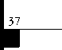

January 2001

Associate

|  |  |
| --- | --- |
| Members | i « |
| MANUFACTURERS | Baldwin Hardware Corp.  1841 E. Wyomissing Blvd., Box 15048  Reading, PA 19612 (610) 736-4012; FAX (610) 796-4493  © (£) |
| A & B Safe Corp.  171 S. Delsea Dr.  Glassboro, NJ 08028 (800) 253-1267; FAX (856) 863-1208  @ (0 © ^ | Buddy Products  1350 S. Leavitt Street  Chicago, IL 60608  (800) 886-8688; FAX (312) 733-8536 |
| Abus Lock Company  3555 Holly Lane North  Plymouth, MN 55447-0507 (800) 352-2287; FAX (612) 509-9939  © | BWD Automotive  900 Raven wood Dr.  Selma, AL 36701  (334) 874-9001; FAX (334) 874-6011  (£) |
| Adams Rite Manufacturing Co.  P.O. Box 1301  LaPuente, CA 91749-1301 (562) 699-0511; FAX (562) 699-5094  ® (|Jl (0 <£) | Chicago Lock Company  10100 88th Ave.  Pleasant Prairie, Wl 53158-0069 (800) 445-3204; FAX (414) 947-7178  © |
| Adesco Safe Manufacturing Co.  web: [www.adesco.com](http://www.adesco.com) email: [sales@adesco.com](mailto:sales@adesco.com) (800) 821-6803; FAX (562) 408-6427 | Corbin Russwin Architectural Hardware  P.O. Box 25288  Charlotte, NC 28229 (800) 543-3658; FAX (800) 447-6714  (|J) igj ® ® |
| Adrian Steel Company  web: [www.adriansteel.com](http://www.adriansteel.com)  Adrian, Ml 49221  (800) 677-2726; FAX (517) 265-5834  © | Curtis Industries  6140 Parkland Blvd, Ste. 300  Mayfield Heights, OH 44124-4103 (800) 555-5397 |
| Alarm Lock Systems, Inc.  345 Bayview Ave.  Amityville, NY 11701 (800) ALA-LOCK; (516) 789-3383  © | DETEX  302 Detex Dr.  New Braunfels, TX 78130 (800) 729-3839; FAX (830) 620-6711  ® (|J) (U <Bj ^ |
| Aiphone Intercom Systems  1700-130th Avenue, NE  Bellevue, WA 98005 (425) 455-0510; FAX (425) 455-0071  @ @ | DSC Group of Companies  3301 Lang staff Road  Concord, Ontario, Canada (905) 760-3000 ext. 2200; FAX (905) 760-3040  © @ (p (g) <$ |
| American Lock Co.  3400 West Exchange Road  Crete, IL 60417-2099 (708) 534-2000; FAX (708) 534-0531  © © | Don-Jo Manufacturing, Inc.  P.O. Box 929  Sterling, MA 01564 (508)422-3377; FAX (508) 422-3467  igl (Q |
| American Security Products (AMSEC)  11925 Pacific Ave.  Fontana, CA 92337-6963 (800) 423-1881; FAX (909)685-9685  <3^ § | Door Controls International  2362 Bishop Circle East  Dexter, Ml 48130  (800)742-3634; FAX (800) 742-0410  @ <u ® |
|  |  |

Associate members of the Associated Locksmiths of America (ALOA) manufacture or distribute materials or equipment, or provide services, for the security industry. Many have donated money, services and equipment to ALOA in addition to their annual dues. Their support of ALOA projects enhances overall membership benefits and we encourage our members to patronize these firms. If you know of a potential candidate for associate membership, please contact the ALOA Membership staff at (800) 5 32-ALOA. Associate member dues are $300 per year and entitle the payor to use the ALOA logo, and receive selected discounts on ALOA products and services.

Legend

**® Alarms:** Personal, vehicle, electronic, fire, burglar, and exit **@ Bank security equipment ® Automotive:** Lockout equipment, key chains/rings

**® Builders Hardware:** Door closers, furniture/decorative hardware, viewers, emergency exit devices **© Business/Technical & Educational:** Books, reference guides, publications, computer software

® **CCTlf/Photo Imaging:** Cameras, monitors, photo ID equipment, cables ® **Electric/Electronic Security:** Card access control and readers, surveil­lance, electric/magnetic locks and strikes, keypads

**® Lock Devices:** Auto locks, cylinders, emergency exit/entrance control, locks (various types), strikes **® Tools & Supplies:** Key blanks, cutters, picks, rings/hooks, custom van/truck supplies

® Safes/Vaults @ Other

ESP Lock Products, Inc.

375 Harvard Street  
Leominster, MA 01453  
(978) 537-6121; FAX (978) 534-9109

© ©

Folger Adam Security, Inc.

16300 W. 103rd Street  
Lemont, IL 60439

(630) 739-3900; FAX (630) 739-6138

© ©

Fort Lock Corp.

3000 N. River Rd.

River Grove, IL 60171  
(708) 456-1100; FAX (708) 456-9476

(|Jl |0) (0 |f», ^

Grobet File Co. of America

750 Washington Ave.  
Carlstadt, NJ 07072  
(800) 962-7242; FAX (800) 243-2432

©

Keynotes

January 2001

|  |  |  |
| --- | --- | --- |
| H.E.S., Inc.  2040 W. Quail Ave.  Phoenix, AZ 85027 (602) 582-4626; FAX (602) 582-4641  • • • | LAB Security  700 Emmett St.  Bristol, CT 06010  (800) 243-8242; FAX (203) 583-7838  • | ROFU International Corp.  2004-B 48th Ave.; Court E  Tacoma, WA 98424 (800) 255-7638; FAX (253) 922-1728  • • • |
| HPC, Inc.  3999 N. 25th Avenue  Schiller Park, IL 60176 (847) 671 -6280; FAX (847) 671 -6343  • • • | LCN Closers (Division of Ingersol)  121 W. Railroad Ave.  Princeton, IL 61356  (815) 875-3311; FAX (815) 875-3222  • | Rutherford Controls Inc.  2697 International Pkwy, Bid 5 #100  Virginia Beach, VA 23452 (757) 427-1230; FAX (757) 427-9549  e |
| HID Corporation  9292 Jeronimo Road  Irvine, CA 92618  (949) 568-1600; FAX (949) 568-1680  • • | La Gard, Inc.  3330 Kashiwa Street  Torrance, CA 90505 (310) 325-5670; FAX (310) 325-5615  (0 | STRATTEC Security Corp.  3333 W. Good Hope Rd.  Milwaukee, Wl 53209 (414) 247-3333; FAX (414) 247-3329  • • • |
| High Tech Tools  1400S.W. 1 Street  Miami, FL 33135  (305) 649-7014; FAX (305) 541-0074  * • | Lucky Line Products  7890 Dunbrook Rd.  San Diego, CA 92126 (619) 549-6699; FAX (619) 549-0949  • | Sargent & Greenleaf, Inc.  P.O. Box 930  Nicholasville, KY 40340-0930 (606) 885-9411; FAX (606) 887-2057  • • • • |
| Hongtai Lock Co. Ltd.  Jidong, Xiaolan Road, Xiolan Zhongshan/Guangdong, China 528415 (86) 137-238-1414; FAX (86) 208-793-3856  • • • • | M.A.G. Engineering & Mfg. Inc.  15381 Assembly Lane  Huntington Beach, CA 92649 (714) 891-5100; FAX (714) 892-6845  • • • | Schlage Lock Co.  1915 Jamboree Suite 165  Colorado Springs, CO 80920 (800) 847-1864; FAX (800) 452-0663  # ® |
| llco Unican  400 Jeffreys Road  Rocky Mount, NC 27804 (252) 446-3321; FAX (252) 446-4702  • •••••• | MARKS USA  5300 New Horizons Blvd.  Amityville, NY 11701 (516) 225-5400; FAX (516) 225-6136  • | Schwab Corporation  110 Professional Court  Lafayette, IN 47905 (765) 447-9470; FAX (765) 447-8278  • |
| In Out Systems, Inc.  3650-B Matte Boulevard  Brossard, Quebec J4Y-2Z2, Canada (450) 444-5949; FAX (450) 444-4856  e t | MARRAY ENTERPRISES  1128 Walsh Avenue  Santa Clara, CA 95050 (408) 970-0213; FAX (408) 970-8767  • • • | Securitron Magnalock Corp.  550 Vista Blvd.  Sparks, NV 89434  (800) 624-5625; FAX (702) 355-5636  e • |
| Intellikey  551 S. Apolo Boulevard, Suite 204  Melbourne, Florida 32901 (800) 226-0703; FAX (407) 724-0811 | MUL-T-LOCK USA, Inc.  300-1 Route 17 South Suite A  Lodi, NJ 07644  (800) 562-3511; FAX (973) 778-4007  • • • | Security Door Controls  3580 Willow Lane  Westlake Village, CA 91361 (805) 494-0622; FAX (800) 959-4732  • |
| Jet Hardware Mfg. Co  800 Hinsdale Street  Brooklyn, NY 11207 (718) 257-9600; FAX (718) 257-0973 | Master Lock Company  2600 North 32nd Street  Milwaukee, Wl 53211 (414) 444-2800; FAX (414) 449-3114  • e | Security Solutions  1640W. Hwy. 152  Mustang, OK 73064 (405) 376-1600; FAX (405) 376-6870  ^ (Q ^ |
| KABA High Security Locks  RO. Box 490  Southington, CT 06489 (860) 621-3601; FAX (860) 621 -9727  • | Medeco Security Locks  P.O.Box 3075  Salem, VA 24153  (540)380-5000; FAX (540) 380-5010  ^ Q 4^ | Sentry Group  900 Linden Ave.  Rochester, NY 14625-2784 (716) 381-4900; FAX (716) 381 -8559  • |
| KEY-BAK; Div. of W. Coast Chain Mfg. Co.  4245 Pacific Privado  Ontario, CA 91761  (909) 923-7800; FAX (909) 923-0024  • • • • | Meilink Safe Company  111 Security Parkway  New Albany, IN 47150 (800) 634-5465; FAX (800) 896-6606  • | Sully Tools Inc.  3515 Nodding Pine Ct.  Fairfax, VA 22033  (703) 689-3416; FAX (703) 787-0869  • • • |
| Knaack Manufacturing Co.  420 E. Terra Cotta Ave.  Crystal Lake, IL 60014 (800) 456-7865; FAX (815) 459-9097  • | One Lock, One Key Inc.  706 Hinsdale Dr  Arlington, TX 76006 (817) 860-1011; FAX (817) 275-6839  • | Taymor Industries, Inc.  1586 Zephyr Ave.  Hayward, CA 94544 (800) 388-9887; FAX (800) 288-8133  # • |

January 2001

***Keynotes***

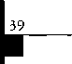

|  |  |  |
| --- | --- | --- |
| Trine Products Corporation  1430 Ferris Place  Bronx, NY 10461  (718) 829-4796; FAX (718) 792-9127  © (0 (g) | ADI  263 Old Country Road  Melville, NY 11747 (516) 692-1000; FAX (516) 692-3457  © © © | E. L. Reinhardt Co., Inc.  3250 Fanum Road  Vadnais Heights, MN 55110 (800) 328-1311; FAX (612) 481-0166  © © (0 © © © |
| Unelko Security Systems Ltd.  14641 N. 74th Street  Scottsdale, AZ 85260 (480) 991-7272; FAX (480) 483-7674  © | Akron Hardware Consultants, Inc.  2579 South Arlington Road  Akron, OH 44319  (800) 321-9602; FAX (800) 328-6070  © © © | Ewert Wholesale Hardware  4709 W 120th St  Alsip ll 60658  (800) 451-0200; FAX (708) 597-0881  © © © © © |
| Videx, Inc.  1105 NE Circle Blvd.  Corvallis, OR 97330 (541) 758-0521; FAX (541) 752-5285  © © © | American Security Distribution  4411 E. La Palma  Anaheim, CA 92807 (714) 996-0791; FAX (714) 579-3508  © © © © © ® © | Fairway Supply, Inc.  2631 Lombardy Lane  Dallas, TX 75220  (214)350-0021; FAX (214) 352-4299  © © © © © © © |
| Visonic, Inc.  10 Northwood Dr  Bloomfield, CT 06002 (800) 223-0020; FAX (860) 242-8094  t | Andrews Wholesale Lock Supply  544 S. 9th St.  Lebanon, PA 17042-6608 (717) 272-7422; FAX (717) 274-8679 | Foley-Belsaw Company  6301 Equitable Road  Kansas City, MO 64120 (800)821-3452; FAX (816) 483-5010  © © © © |
| W-Lok Corporation  675 East 16th Street, Suite 111  Holland, Ml 49423  (616) 355-4015; FAX (616) 355-4295  © | Boyle & Chase Inc.  P. O. Box 74  Accord, MA 02018-0074 (800) 325-2530; FAX (800) 205-3500  © © © | Fried Brothers, Inc.  467 N. 7th St.  Philadelphia, PA 19123 (800) 523-2924; FAX (800) 541 -3489  ©©©©©©©©©© |
| Weiser Lock Company  6700 Weiser Lock Blvd.  Tucson, AZ 85746  (502) 741-6338; FAX (520) 741-6363  <3}) (0 | Clark Security Products, Inc.  4775 Viewridge Ave.  San Diego, CA 92123-1641 (800) 854-2088; FAX (619) 974-5284  ©©©©©©©©©©| | HS&S Wholesale Distributors  12915 West 8 Mile Road  Detroit, Ml 48235  (800) 521 -2202; FAX (313) 342-7580  © © © © © © © |
| Wilson Bohannan Company  621 Buckeye Street  Marion, OH 43301-0504 (800) 382-3639; FAX (740) 383-1653  © | Cook's Building Specialties  2441 Menaul Blvd. NE; P.O. Box 37320 Albuquerque, NM 87176-7320 (505)883-5701; FAX (505) 883-5704  © © © (0 © © | Hans Johnsen Company  8901 Chancellor Row  Dallas, TX 75247  (214) 879-1550; FAX (214) 879-1530  ©©©©©©©© |
| Yale Security Inc.  P.O. Box 25288  Charlotte, NC 28229-8010 (800) 438-1951; FAX (800) 338-0965  © © © © | DiMark International  3117 Liberator St., Unit A  Santa Maria, CA 93455 (800) 235-2435; FAX (805) 928-8034  © © © © © | Hardware Agencies, Ltd.  1220 Dundas Street East  Toronto, ON M4M 1S3 (416) 462-1921; FAX (414) 462-1922  ©©©©©©©© |
| Zhongshan Hua Feng Lock Products  S Yongning Industrial Road, Ziaolan Zhongshan Guangdong, China  86-760 227 82 63; FAX 86-270 227 80 63  © | Dire's Lock & Key Co.  2201 Broadway  Denver, CO 80205  (303) 294-0176; FAX (303) 294-0198  ©©©©©©©©©©© | Hardware Suppliers of America  P.O. Box 2208  Winterville, NC 28590 (800) 334-5625; FAX (800) 334-5635  © © |
| DISTRIBUTORS | Direct Security Supply, Inc.  36 Lincoln Street  Boston, MA 02135  (800) 252-5757; FAX (800) 452-8600  © © © © © © © | High Tech Tools  1400S.W. 1 Street  Miami, FL 33135  (305) 649-7014; FAX (305) 541-0074  © © |
| Accredited Lock Supply Co.  P.O. Box 1442  Secaucus, NJ 07096-1442 (800) 652-2835; FAX (201) 865-5031  © © © © © © © | Doyle Security Products  2211 W. River Road N.  Minneapolis, MN 55411 (800) 333-6953; FAX (612) 521-0166  ©©©©©©©©©©© | Howard Keys  130 Stetson Dr  Charlotte, NC 28262 (704) 598-2291; FAX (704) 598-9110  <9  IDN, Inc.  2401 Mustang Drive, Suite 100  Grapevine, TX 76051 (817)421-5470; FAX (817) 421-5468  ©©©©©©(0©©© |
| Ace Lock & Security Supply Co.  565 Rahway Ave.  Union, NJ 07083-6631 (800) ACE-LOCK; (800) ACE-FAX4  ©©©©©©©© | Dugmore & Duncan Inc.  30 Pond Park Rd.  Hingham, MA 02043 (888) 384-6673; FAX (888) 329-3846  © © © © © (5 © |

401

***Keynotes***

January 2001

|  |  |  |
| --- | --- | --- |
| Intermountain Lock & Supply Co  3106 South Main Street  Salt Lake City, Utah 84115 (800) 453-5386; FAX (801) 485-7205 | Securite.com  4775 Viewridge Avenue  San Diego, CA 92123 (800) 241 -3930; FAX (619) 974-5269  (0 0 0 | U.S. Lock Corporation  77 Rodeo Drive  Brentwood, NY 11717 (800) 925-5000; FAX (800) 338-5625  0 0 © 0 0 |
| JLM Wholesale, Inc.  3095 Mullins Ct  Oxford, Ml 48371-1643 (800) 522-2940; FAX (800) 782-1160  © (0 (0 | Omaha Wholesale Hardware  1201 Pacific Street, PO Box 3628  Omaha, NE 68108 (800) 238-4566  00000000 | Webster Safe & Lock Company, Inc.  3020 Millbranch  Memphis, TN 38116 (901) 332-2911; FAX (901) 332-2878  0 0 0 0 (0 © 0 |
| Jo-Van Distributors Inc.  929 Warden Ave.  Scarborough, Ontario Ml L 4C6 (416) 752-7249; FAX (416) 752-3845  000(0)0000000 | Security Lock Distributors  40 A Street  Needham Heights, MA 02194 (800) 847-5625; FAX (800) 878-6400  0 0 0 | SERVICE |
| Lockmasters, Inc.  5085 Danville Road  Nicholasville KY, 40356 (800) 654-0637; FAX (859) 885-7093  0 0 0 0 | Sentry Security Fasteners  8109 N. University  Peoria, IL 61615  (309) 693-2800; FAX (309) 693-2872  $ ® | 1 -(800) Tow Truck, Inc.  190 Main Street  Hackensack, NJ 07601 (800) 835-4187; FAX (800) 835-4189 |
| Locks Company  2050 N.E. 151 St.  N. Miami, FL 33162 (800) 288-0801; FAX (305) 949-3619  0 0 0 0 0 0 0 | Southern Lock and Supply Co.  Box 1980, 10910 Endeavor Way  Pinellas Park, FL 33780 (800) 237-2875; FAX: (800) 447-2299  000000000 | Alarm Monitoring Service, Inc.  5021 Fairfield St.  Metairie, LA 70006 (504) 454-2163; (504) 456-8737  ® |
| The Locksmith Store Inc.  1229 E Algonquin Rd. Suite E  Arlington Heights, IL 60005 (847) 364-5111; FAX (847) 364-5125  0 0 © 0 | Stone & Berg Wholesale  99 Stafford Street  Worcester, MA 01603 (800) 225-7405; FAX (800) 535-5625  0000000000 | Allstate Insurance Company  2775 Sanders Road, Suite A5  Northbrook, IL 60062 (847) 402-8196; FAX (847) 326-7509  ® |
| M. Zion Company  69 Reade Street, 4th Floor  New York, NY 10007 (212) 349-8677; FAX (212) 964-0495  0 0 0 0 0 0 0 | Strauss Safe & Lock Company  1801 Second Avenue  Des Moines, IA 50314 (515)288-9571; FAX: (515) 288-9752  0 0 0 © 0 0 | Diamond Software  2952 N. Expressway  Griffin, GA 30223  (770) 227-7650; FAX (770) 227-1699  @ |
| McDonald-DASH Locksmith Supply  5767 E. Shelby Dr.  Memphis, TN 38141 (800) 238-7541; FAX (901) 366-0005  00000000 | Tanner Bolt & Nut Corporation  4302 Glenwood Road  Brooklyn, NY 11210 (718) 434-4502; FAX (718) 434-3215  ® | Locksmith Publishing Corp.  850 Busse Hwy.  Park Ridge, IL 60068 (847) 692-5940; FAX (847) 692-4604 |
| McManus Locksmith Supply, Inc.  P.O. Box 9231, 1309 Central Ave.  Charlotte, NC 28299 (702) 333-9112; FAX (704) 332-8664  © 0 0 © 0 0 | Taylor Securtiy & Lock Co.  8585 Atlas Drive  Gaithesburg, MD 20877 (301) 948-7670; FAX (301) 948-1029  0 0 0 0 | ® Alarms  © Bank Security Equip.  ® Automotive  IS* Builders Hardware <£* Business/Tech & Ed.  © CCTV/Photo Imaging ® Electric/Electronic Security ® Lock Devices ® Tools & Supplies © Safes/Vaults  ® Other |
| McMaster-Carr Supply Company  600 County Line Rd,  Elmhurst, IL 60126-2081 (630) 833-0300; FAX (630) 834-9427  0 0 0 0 0 0 | Timemaster, Inc.  127 SE 29th Street  Topeka, KS 66605  (785) 232-8705; FAX (800) 798-8463  0 <U 0 © 0 0 0 |
| MARRAY ENTERPRISES  1128 Walsh Avenue  Santa Clara, CA 95050 (408) 970-0213; FAX (408) 970-8767  0 0 0 | Top Notch Distributors, Inc.  3151 Goni Rd.  Carson City, NV 89706-7922 (800) 722-4210; FAX (800) 248-3620  0 0 © |
| Monaco Lock Co.  339-345 Newark Ave.  Jersey City, NJ 07302 (800) 526-6094; FAX (800) 845-LOCK  0 0 0 | Turn 10  P. O. Box 746  Marietta, OH m45750 (800) 848-9790; FAX (800) 391-4553  0 0 |
|  |  |

January 2001

Keynotes **1**

Keynotes

Authors



Claire L. Cohen, the second woman to  
become a CML, has been in locksmithing  
since 1977 and has been writing articles for  
Keynotes since 1987. She is also a con-

tributing editor for Keynotes.

Boh Cronk is the national sales manager  
for Select Products Limited in Portage, ML

yil Sal Dulcamaro, CML, has been in the locksmith business for over 23 years. He is

1\ I the president of All Pro Security, Inc. in

Michigan and has been an ALOA member for 18 years. A past president of the Locksmith Security Association of Michigan. Sal currently serves as editor of the association newsletter. He ivas named “Keynotes Author of the Year” for 1996 and 1997. He is also a contribut­ing editor for Keynotes.

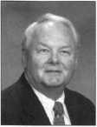

Joseph Arkin holds a BA degree from St. Johns University, and a MBA degree from Pace University. He has written extensively for trade and professional magazines. He is a licensed CPA in the states of New York and Florida.

Keynotes  
Advertisers Index

Advertisers Page

ALOA 2001 43

Hickok IFC

Marray Enterprises, Inc. 23

MLA of New Jersey 16

MasterLink Security Products 23

SAFETECH 2001 IBC

Safe Tech Reference Manual 9

Select Products Ltd. 28

Stam Insight 1

Stone & Berg 17

Texas Locksmiths Association 24 The National Locksmith BC

Turn 10 7

Keynotes

January 2001

|| : 4 £mH||[|



year one,

do you know what to expect

when tomorrow arrives?



witness the

unexpected

atbaltimore convention center.

july 15-22

CL> I

CM

VO!

LO

<N

oil

on

vol

fli

**>**

**c**

**o**

**u**

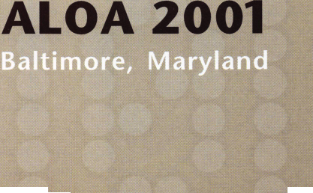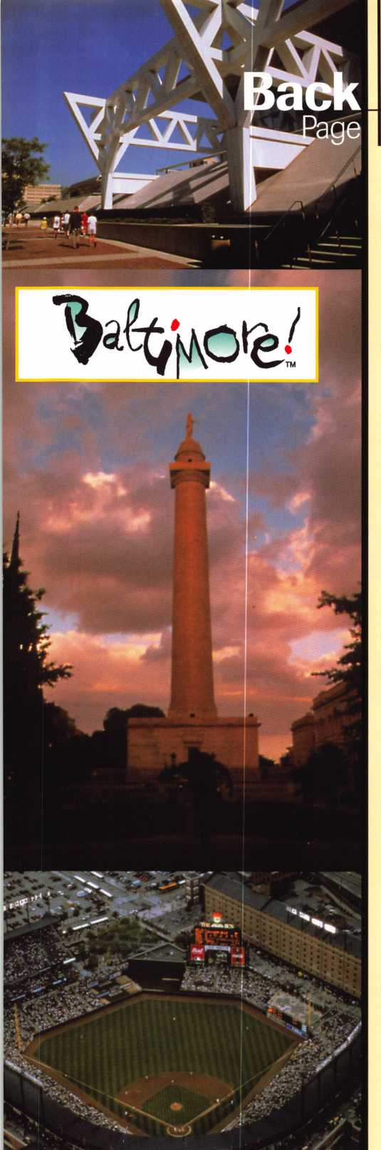

Baltimore here we come!

Yes, 2001 has arrived! That means it’s time to start looking toward the ALOA 2001 Security Expo in Baltimore, July 15-22.

While you start preparing for the trip, we would like to help you familiarize yourself with the city and what it has to offer. Let’s start with sports, both past and present.

Did I forget to mention prizes? Three lucky winners will receive a special prize. Good luck!

1. What year was the first outdoor polo game at night held in Baltimore at Homewood Field?
2. What is the name of Baltimore’s professional football team?
3. What is the name of Baltimore’s baseball park?
4. Who was the czar of Baltimore baseball from 1907 to 1928?
5. What years did the Baltimore Orioles win the World Series?
6. What is the name of the horse race, held in Baltimore, that awards the second jewel of the Triple Crown?
7. What is the name of the racetrack where it takes place?

Mail fax or email your responses to:

Baltimore Sports Trivia do Keynotes 3003 Live Oak Street Dallas, TX 75204 (214) 827-1810 fax [keynotes@aloa.org](mailto:keynotes@aloa.org)



WITH IT.

BEFORE ANYONE ELSE FINDS OUT, LOOK INTO SAFETECH 2001

When professionals don't keep up with the evolution of their industry it shows.

It shows in loss of business, of revenue, of customer confidence.

Focus on where your professional future is going at SAFETECH 2001 in St. Louis, Missouri.

In a city that fires the imagination, you will discover safe technology advances you never imagined possible.  
For more information call 214.827.7233, or email [convention@savta.org](mailto:convention@savta.org).

SAFETECH 2001—A Safe Odyssey.

SAFETECH

**2001**

A SAFE ODYSSEY



ST. LOUIS, MO APRIL 30-MAY 5



**F„the ultimate automotive software for locksmiths’:**

*21:%‘ocUd*

*chasel* ^

***Take an online tour at  
[www.AutoSmartAdvisor.com](http://www.AutoSmartAdvisor.com)***

gimBW

**Key Usage:** All

**See all data including spaces/depths, key blanks, parts, code locations and more.**

**Choose the car**



**Click “Parts Dept” to select which parts you need for the job.**

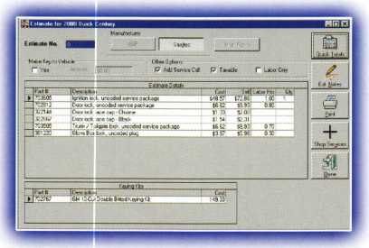

AutoSmart Advisor™ does everything instantly and accurately. Now your computer is the best automotive tool you own!

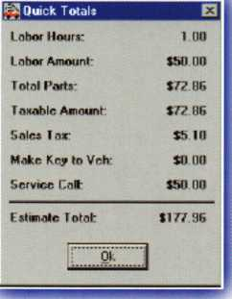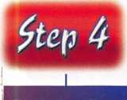

**Click “Quick Totals” for an on screen instant estimate. Or click “Print” to print a professional estimate.**

Installation and System requirements: License is granted to run the software on any two computers you own. Installation on additional computers is available for $50 each. Requires 486 or better PC with Windows 95 or better and CD drive. 75 megabytes of hard drive space. Installable from 17 diskettes which you can create from the CD. 16 megabytes of ram. Not network compatible.

**□** American Express **□** Money Order

Order Total .

Card Number

* YES! Send me the AutoSmart Advisor™ for $395  
  (installable on two computers) plus $5 for shipping  
  and handling. Orders must be paid in US. funds.
* Send me additional licenses for $50 each.
* Send me the 21 day full trial AutoSmart Advisor™

*Demo* for $10 (credited toward full version purchase)

Select payment Method:

**□** Check **□** VISA **□** MasterCard **□** Discover Phone

Signature (required) _ Name

Shop Name

Address (no P.O. boxes) _ City

E-Mail (optional)_

Exp. Date

.State .

Zip

Copy or dip this coupon and send with payment to:

The National Locksmith • P.O. Box 77-97592 • Chicago, Illinois 60678-7592

